
Reach for the Star | GCSE Mathematics 1MA1 | L061

Knowledge organiser: Simultaneous equations
Objective: Solve simultaneous equations and interpret the solution as a common point.
Calculator condition: Non-calculator core; calculator optional only for checking where labelled.
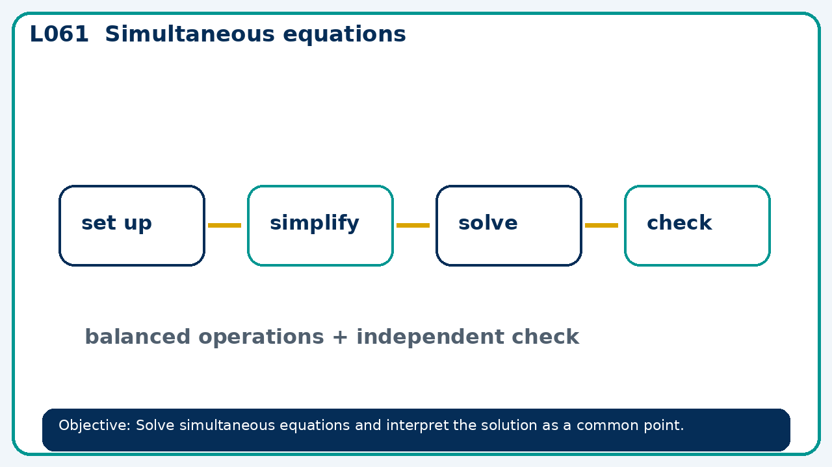

Core knowledge
- Eliminate or substitute and check both equations; Higher: linear–quadratic systems

Method checklist
- Identify what the question is asking.
- Choose the relevant representation or method.
- Show working clearly and label units.
- Check the answer against the original context.
- Write one sentence explaining why the answer is reasonable.

Common error to avoid
- Can x+y=5 and 2x+2y=12 have a solution? Justify.

