
Reach for the Star | GCSE Mathematics 1MA1 | L062

Knowledge organiser: Equations from situations
Objective: Translate a situation into equations and interpret solutions in context.
Calculator condition: Non-calculator core; calculator optional only for checking where labelled.
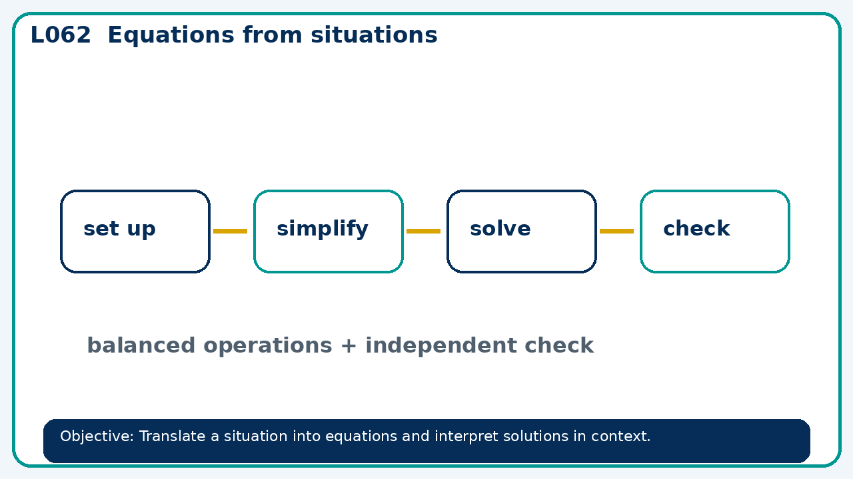

Core knowledge
- Define variables with units; reject solutions that violate the situation

Method checklist
- Identify what the question is asking.
- Choose the relevant representation or method.
- Show working clearly and label units.
- Check the answer against the original context.
- Write one sentence explaining why the answer is reasonable.

Common error to avoid
- A rectangle's length is twice its width and its area is 50 cm². Find positive dimensions.

