
Reach for the Star | GCSE Mathematics 1MA1 | L062

Learner workbook: Equations from situations
Objective: Translate a situation into equations and interpret solutions in context.
Calculator condition: Non-calculator core; calculator optional only for checking where labelled.
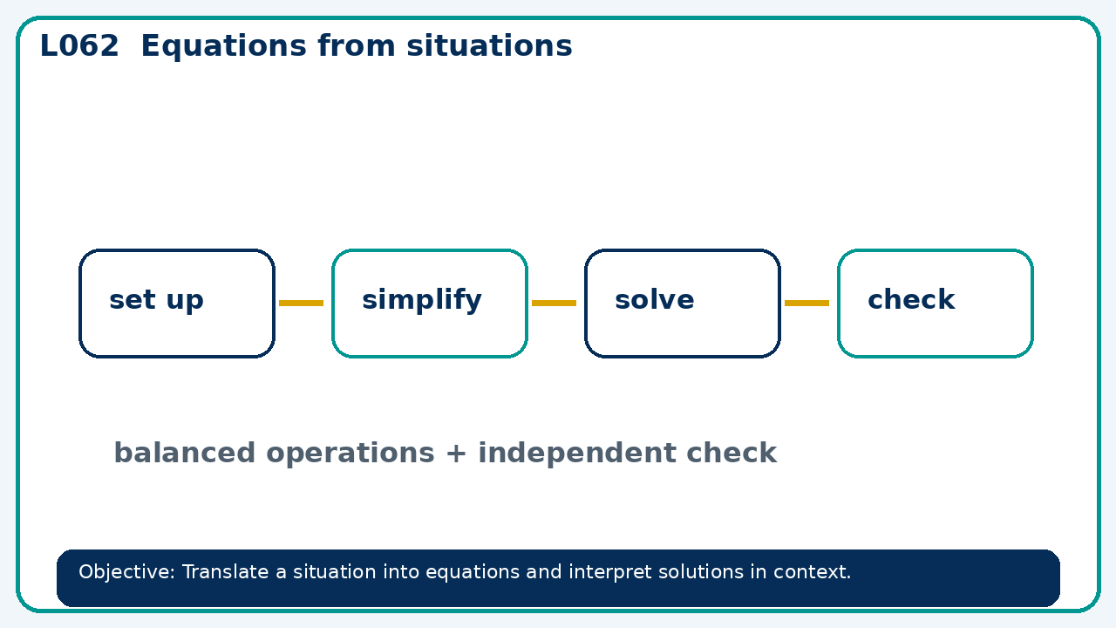

Connect & Check
- State the objective and timeline. Retrieve simultaneous equations or a prerequisite. Diagnose a common error before modelling.
- Write one starting question you want answered today.

Choose your route
Route A: Visual  Use a diagram, graph, table or annotation first. | Route B: Method  Use a worked method, formula or calculation chain first. | Route C: Explain  Start with words: what is known, what is changing, and why.

Share
- Pairs compare methods or predict a result for equations from situations. Ask for a reason, not only an answer.

Present
- Define variables with units; reject solutions that violate the situation

Apply: supported to independent
Recall: Retrieve the key fact or method needed for equations from situations.
Working: ______________________________________________________________
Check/explanation: ____________________________________________________
Core practice: Three adult tickets and two child tickets cost £37. Adults cost £9 each. Find child price.
Working: ______________________________________________________________
Check/explanation: ____________________________________________________
Reasoning: A rectangle's length is twice its width and its area is 50 cm². Find positive dimensions.
Working: ______________________________________________________________
Check/explanation: ____________________________________________________
Exam-style: Solve an exam-style problem involving equations from situations. Show working, include a check and interpret your answer.
Working: ______________________________________________________________
Check/explanation: ____________________________________________________

Recall & Review
- Revisit the objective. Learners solve a fresh item without prompts, explain a check, correct one error and record the next practice.
WWW: ________________________________ EBI: ________________________________

Recall & Review: feedback and extension integration
Lesson L062: Equations from situations
Objective: Translate a situation into equations and interpret solutions in context.
Timing for a 60-minute lesson
0-7 Connect & Check; 7-14 Share; 14-25 Present/model; 25-44 Apply route choice/practice; 44-52 independent exam-style check; 52-60 Recall & Review, WWW/EBI and next step.
Recall & Review evidence
At the end of the lesson, solve a fresh question without prompts, explain one check, correct one error and record the next practice step.
What Went Well (WWW)
I represented the algebraic structure accurately, kept each transformation valid and checked the result by substitution, graph or equivalent reasoning.
Even Better If (EBI)
I will show the missing inverse operation or algebraic step, keep signs and brackets accurate and test the result in the original relationship.
Integrated stretch and deep challenge
Stretch: Three adult tickets and two child tickets cost £37. Adults cost £9 each. Find child price.
Deep challenge: A rectangle's length is twice its width and its area is 50 cm². Find positive dimensions.
My next-step response

