
Reach for the Star | GCSE Mathematics 1MA1 | L063

Knowledge organiser: Cubic reciprocal and other graphs
Objective: Recognise graph families and estimate solutions graphically.
Calculator condition: Calculator allowed where labelled; non-calculator reasoning remains required.
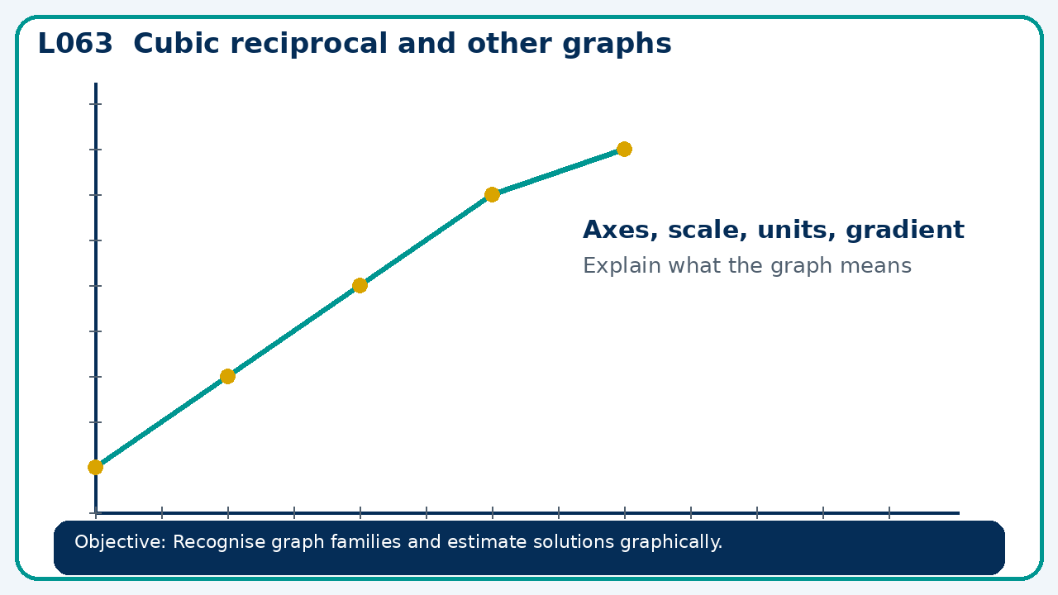

Core knowledge
- Compare cubic and reciprocal graphs; Higher: exponential and trigonometric forms

Method checklist
- Identify what the question is asking.
- Choose the relevant representation or method.
- Show working clearly and label units.
- Check the answer against the original context.
- Write one sentence explaining why the answer is reasonable.

Common error to avoid
- Compare y=x³ and y=−x³ at x=−2 and x=2. What symmetry relates them?

