
Reach for the Star | GCSE Mathematics 1MA1 | L064

Knowledge organiser: Cumulative checkpoint 4 and feedback
Objective: Apply number accuracy, graphs and equations in cumulative tasks.
Calculator condition: Non-calculator core; calculator optional only for checking where labelled.
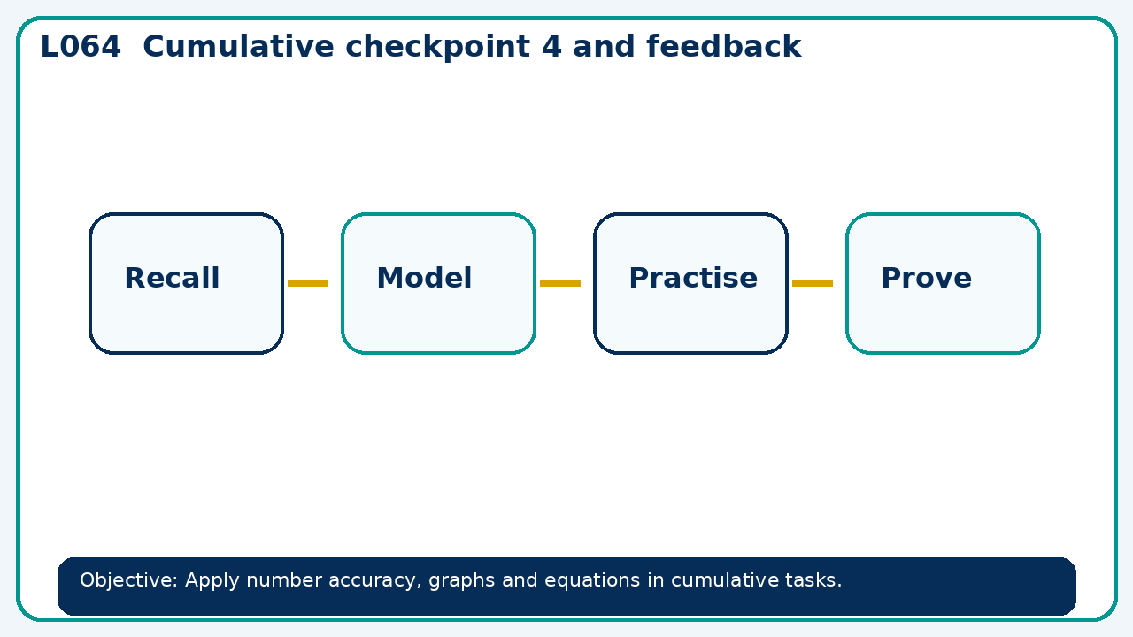

Core knowledge
- Diagnose whether errors arise in modelling, manipulation or checking

Method checklist
- Identify what the question is asking.
- Choose the relevant representation or method.
- Show working clearly and label units.
- Check the answer against the original context.
- Write one sentence explaining why the answer is reasonable.

Common error to avoid
- A student obtains x=2,y=3 from x+y=5 and x−y=1. Test and repair.

