
Reach for the Star | GCSE Mathematics 1MA1 | L065

Knowledge organiser: Direct and inverse proportion
Objective: Solve direct and inverse proportion problems and represent relationships.
Calculator condition: Non-calculator core; calculator optional only for checking where labelled.
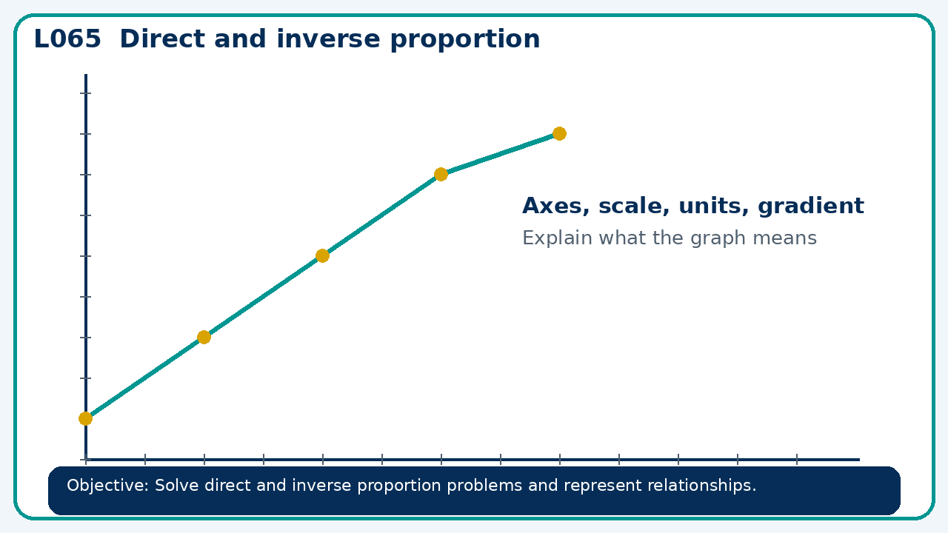

Core knowledge
- Use tables, graphs and equations; distinguish proportional from merely increasing relationships

Method checklist
- Identify what the question is asking.
- Choose the relevant representation or method.
- Show working clearly and label units.
- Check the answer against the original context.
- Write one sentence explaining why the answer is reasonable.

Common error to avoid
- A graph through the origin appears curved upward. Can y be directly proportional to x? Explain.

