
Reach for the Star | GCSE Mathematics 1MA1 | L065

Learner workbook: Direct and inverse proportion
Objective: Solve direct and inverse proportion problems and represent relationships.
Calculator condition: Non-calculator core; calculator optional only for checking where labelled.
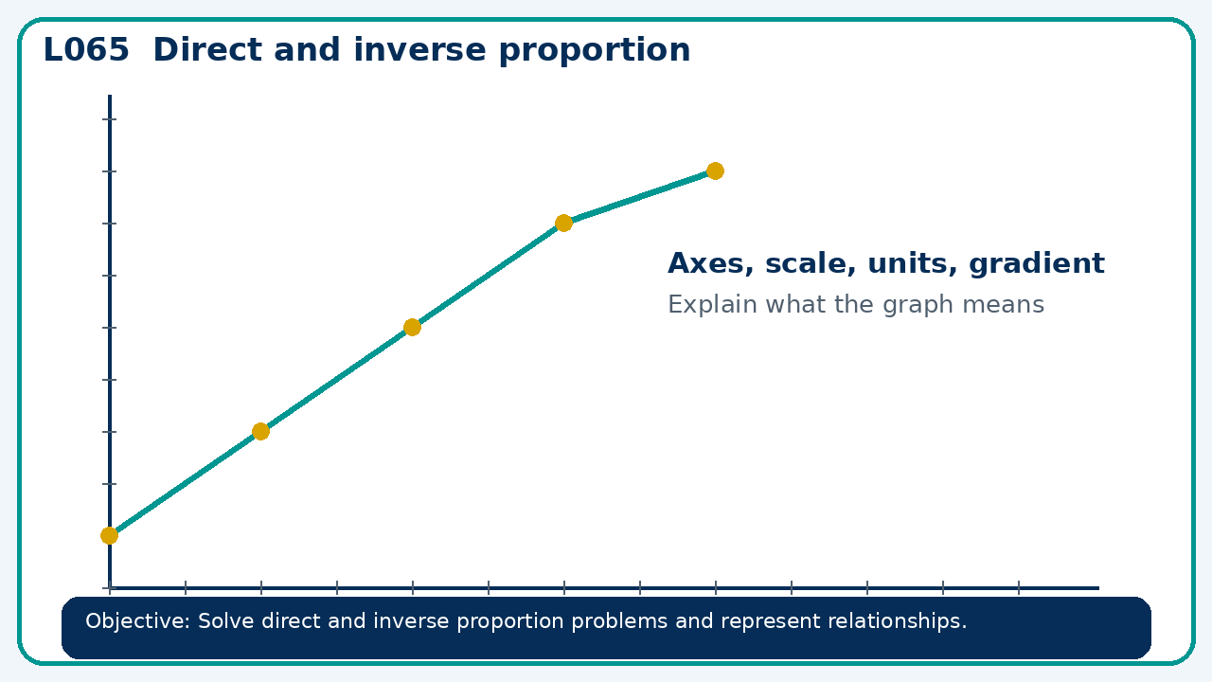

Connect & Check
- State the objective and timeline. Retrieve cumulative checkpoint 4 and feedback or a prerequisite. Diagnose a common error before modelling.
- Write one starting question you want answered today.

Choose your route
Route A: Visual  Use a diagram, graph, table or annotation first. | Route B: Method  Use a worked method, formula or calculation chain first. | Route C: Explain  Start with words: what is known, what is changing, and why.

Share
- Pairs compare methods or predict a result for direct and inverse proportion. Ask for a reason, not only an answer.

Present
- Use tables, graphs and equations; distinguish proportional from merely increasing relationships

Apply: supported to independent
Recall: Retrieve the key fact or method needed for direct and inverse proportion.
Working: ______________________________________________________________
Check/explanation: ____________________________________________________
Core practice: y is inversely proportional to x². If y=12 at x=2, find y at x=4.
Working: ______________________________________________________________
Check/explanation: ____________________________________________________
Reasoning: A graph through the origin appears curved upward. Can y be directly proportional to x? Explain.
Working: ______________________________________________________________
Check/explanation: ____________________________________________________
Exam-style: Solve an exam-style problem involving direct and inverse proportion. Show working, include a check and interpret your answer.
Working: ______________________________________________________________
Check/explanation: ____________________________________________________

Recall & Review
- Revisit the objective. Learners solve a fresh item without prompts, explain a check, correct one error and record the next practice.
WWW: ________________________________ EBI: ________________________________

Recall & Review: feedback and extension integration
Lesson L065: Direct and inverse proportion
Objective: Solve direct and inverse proportion problems and represent relationships.
Timing for a 60-minute lesson
0-7 Connect & Check; 7-14 Share; 14-25 Present/model; 25-44 Apply route choice/practice; 44-52 independent exam-style check; 52-60 Recall & Review, WWW/EBI and next step.
Recall & Review evidence
At the end of the lesson, solve a fresh question without prompts, explain one check, correct one error and record the next practice step.
What Went Well (WWW)
I identified the correct reference quantity, ratio, rate or multiplier and kept the units and proportional relationship clear.
Even Better If (EBI)
I will state the whole or reference quantity, show the multiplier or unit-rate step and check whether the result is sensible in context.
Integrated stretch and deep challenge
Stretch: y is inversely proportional to x². If y=12 at x=2, find y at x=4.
Deep challenge: A graph through the origin appears curved upward. Can y be directly proportional to x? Explain.
My next-step response

