
Reach for the Star | GCSE Mathematics 1MA1 | L066

Knowledge organiser: Speed density and pressure
Objective: Use speed, density and pressure with consistent units.
Calculator condition: Calculator allowed where labelled; non-calculator reasoning remains required.
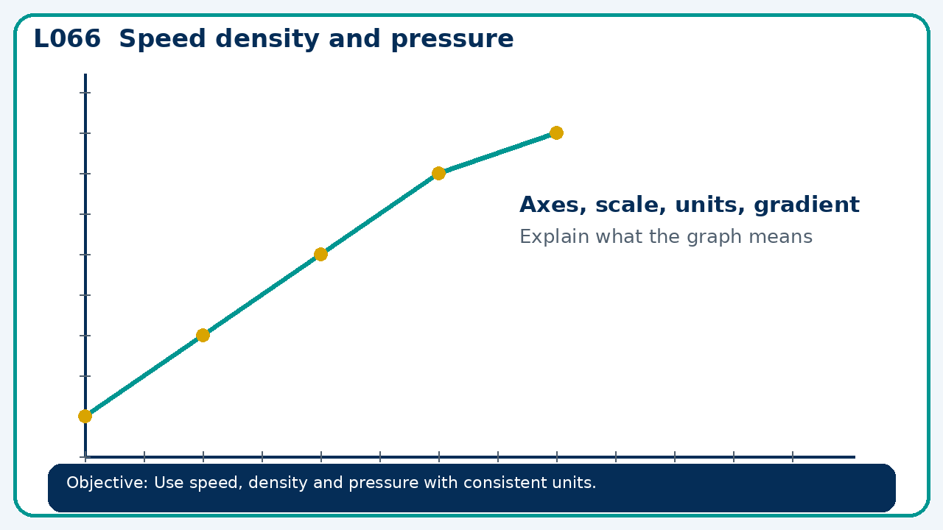

Core knowledge
- Rearrange compound-measure relationships; estimate before calculator work

Method checklist
- Identify what the question is asking.
- Choose the relevant representation or method.
- Show working clearly and label units.
- Check the answer against the original context.
- Write one sentence explaining why the answer is reasonable.

Common error to avoid
- Pressure doubles while force is constant. What happened to contact area? Explain algebraically.

