
Reach for the Star | GCSE Mathematics 1MA1 | L067

Knowledge organiser: Growth decay and compound interest
Objective: Model repeated percentage change, growth, decay and compound interest.
Calculator condition: Non-calculator core; calculator optional only for checking where labelled.
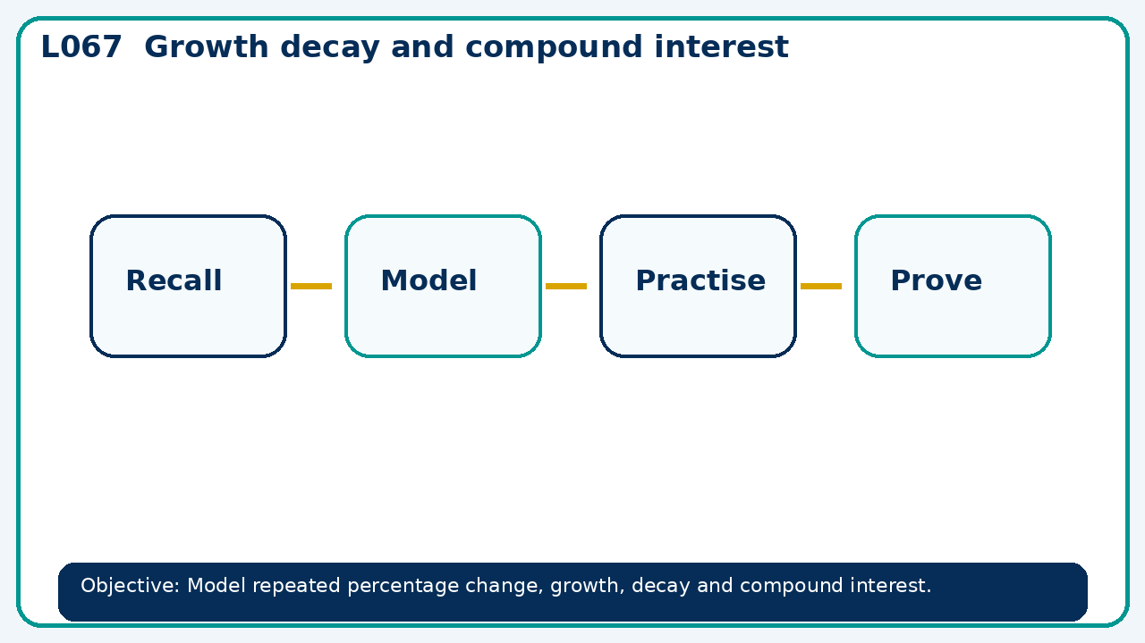

Core knowledge
- Compare additive and multiplicative change using successive periods

Method checklist
- Identify what the question is asking.
- Choose the relevant representation or method.
- Show working clearly and label units.
- Check the answer against the original context.
- Write one sentence explaining why the answer is reasonable.

Common error to avoid
- A price rises 20% then falls 20%. Prove it does not return to the starting price.

