
Reach for the Star | GCSE Mathematics 1MA1 | L068

Knowledge organiser: Rates pathway and repair
Objective: Select a proportion or rate method and explain assumptions.
Calculator condition: Non-calculator core; calculator optional only for checking where labelled.
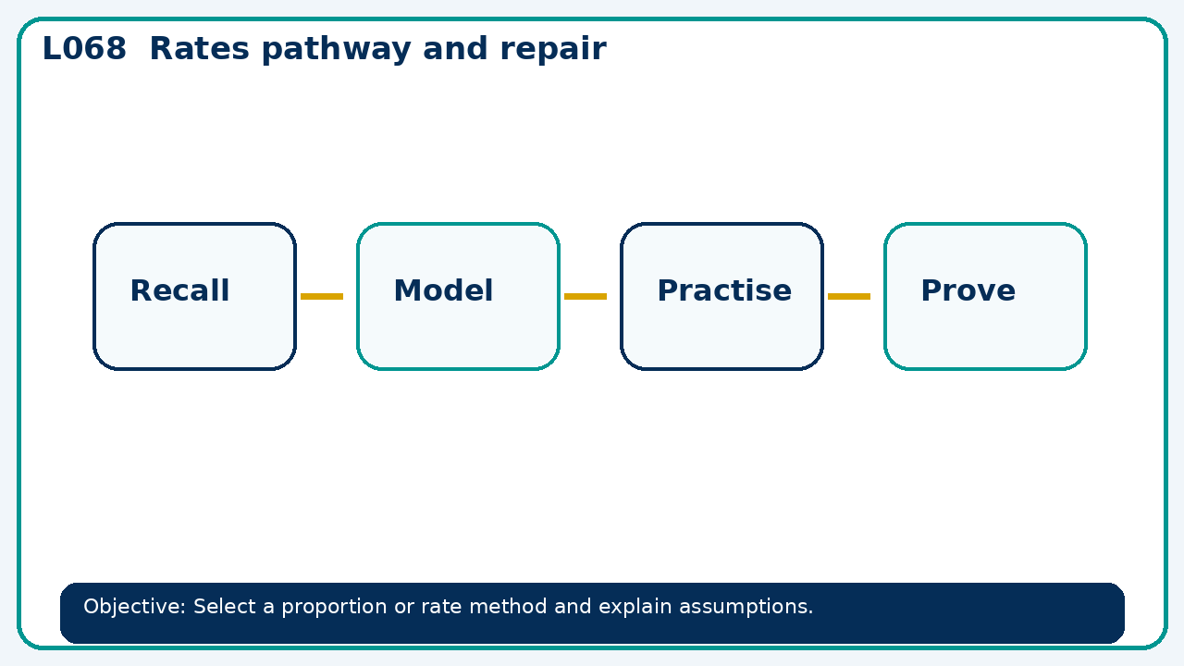

Core knowledge
- Foundation: unit rates and percentages.
- Higher: non-linear proportion and iterative growth

Method checklist
- Identify what the question is asking.
- Choose the relevant representation or method.
- Show working clearly and label units.
- Check the answer against the original context.
- Write one sentence explaining why the answer is reasonable.

Common error to avoid
- A distance is fixed. If speed increases by 25%, what happens to journey time?

