
Reach for the Star | GCSE Mathematics 1MA1 | L069

Knowledge organiser: Similarity and lengths
Objective: Use similarity to calculate missing lengths and justify scale factors.
Calculator condition: Non-calculator core; calculator optional only for checking where labelled.
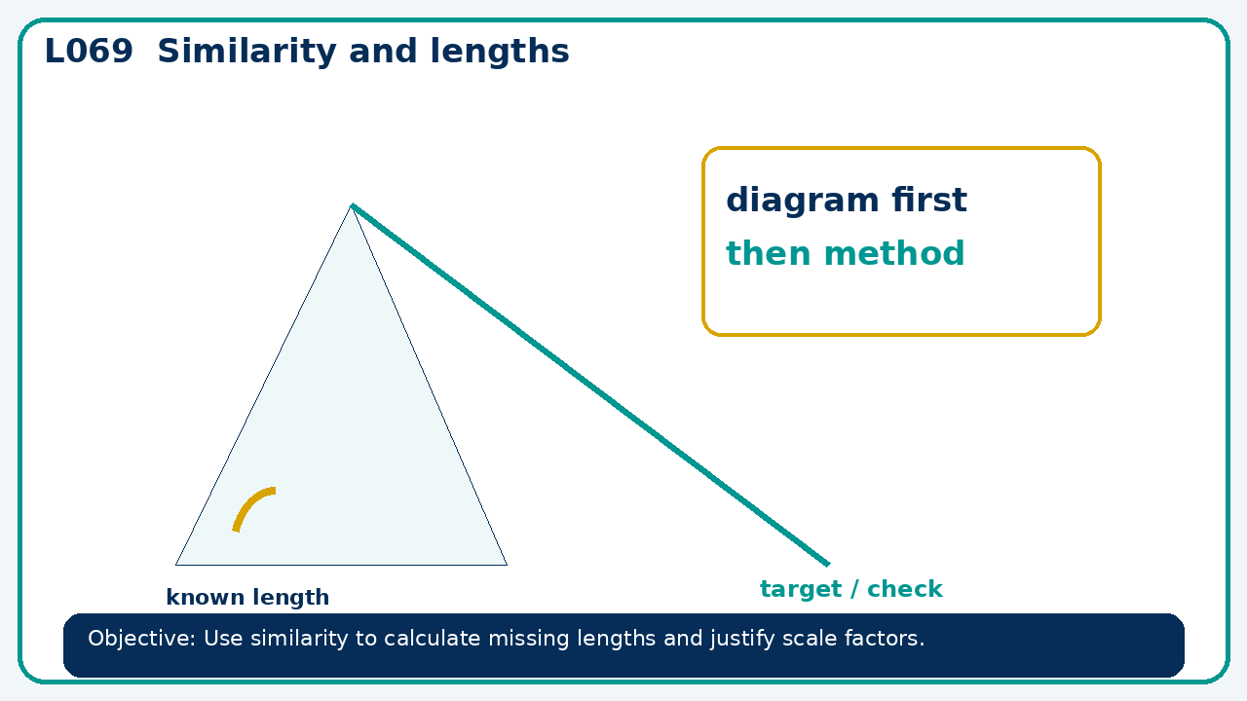

Core knowledge
- Match corresponding vertices before calculating; contrast similarity with congruence

Method checklist
- Identify what the question is asking.
- Choose the relevant representation or method.
- Show working clearly and label units.
- Check the answer against the original context.
- Write one sentence explaining why the answer is reasonable.

Common error to avoid
- Are triangles with side sets 3,4,5 and 6,8,11 similar? Explain.

