
Reach for the Star | GCSE Mathematics 1MA1 | L070

Knowledge organiser: Area and volume scale factors
Objective: Connect linear scale factors with area and volume change at the appropriate tier.
Calculator condition: Calculator allowed where labelled; non-calculator reasoning remains required.
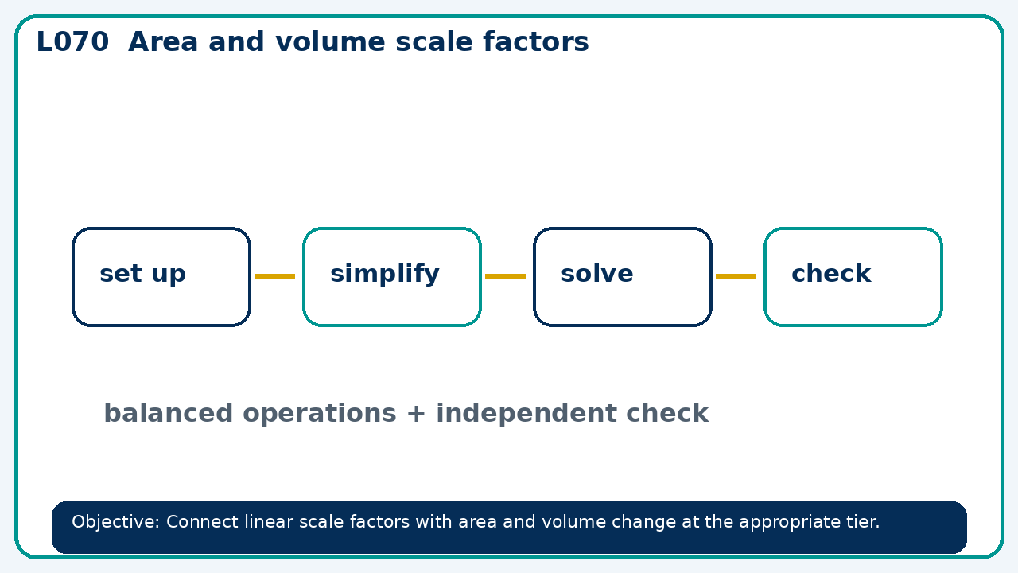

Core knowledge
- Foundation: revisit length scale and direct area/volume calculation.
- Higher: squared and cubed scale factors

Method checklist
- Identify what the question is asking.
- Choose the relevant representation or method.
- Show working clearly and label units.
- Check the answer against the original context.
- Write one sentence explaining why the answer is reasonable.

Common error to avoid
- Volume ratio of similar solids is 27:64. Find length and area ratios.

