
Reach for the Star | GCSE Mathematics 1MA1 | L070

Learner workbook: Area and volume scale factors
Objective: Connect linear scale factors with area and volume change at the appropriate tier.
Calculator condition: Calculator allowed where labelled; non-calculator reasoning remains required.
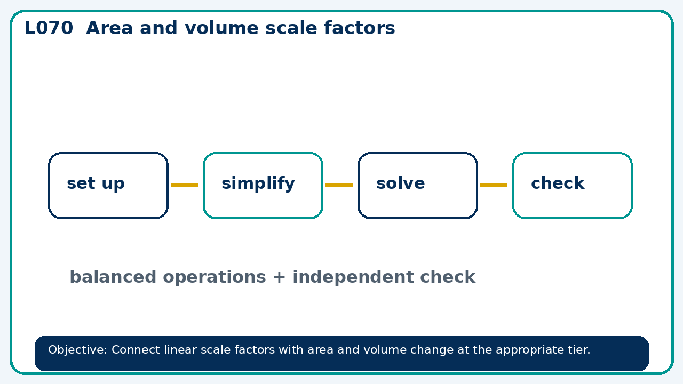

Connect & Check
- State the objective and timeline. Retrieve similarity and lengths or a prerequisite. Diagnose a common error before modelling.
- Write one starting question you want answered today.

Choose your route
Route A: Visual  Use a diagram, graph, table or annotation first. | Route B: Method  Use a worked method, formula or calculation chain first. | Route C: Explain  Start with words: what is known, what is changing, and why.

Share
- Pairs compare methods or predict a result for area and volume scale factors. Ask for a reason, not only an answer.

Present
- Foundation: revisit length scale and direct area/volume calculation.
- Higher: squared and cubed scale factors

Apply: supported to independent
Recall: Retrieve the key fact or method needed for area and volume scale factors.
Working: ______________________________________________________________
Check/explanation: ____________________________________________________
Core practice: Two similar solids have lengths ratio 3:4 and smaller surface area 54 cm². Find larger area.
Working: ______________________________________________________________
Check/explanation: ____________________________________________________
Reasoning: Volume ratio of similar solids is 27:64. Find length and area ratios.
Working: ______________________________________________________________
Check/explanation: ____________________________________________________
Exam-style: Solve an exam-style problem involving area and volume scale factors. Show working, include a check and interpret your answer.
Working: ______________________________________________________________
Check/explanation: ____________________________________________________

Recall & Review
- Revisit the objective. Learners solve a fresh item without prompts, explain a check, correct one error and record the next practice.
WWW: ________________________________ EBI: ________________________________

Recall & Review: feedback and extension integration
Lesson L070: Area and volume scale factors
Objective: Connect linear scale factors with area and volume change at the appropriate tier.
Timing for a 60-minute lesson
0-7 Connect & Check; 7-14 Share; 14-25 Present/model; 25-44 Apply route choice/practice; 44-52 independent exam-style check; 52-60 Recall & Review, WWW/EBI and next step.
Recall & Review evidence
At the end of the lesson, solve a fresh question without prompts, explain one check, correct one error and record the next practice step.
What Went Well (WWW)
I selected the correct geometric fact, theorem, formula or transformation and used a clear diagram with appropriate labels and units.
Even Better If (EBI)
I will name the fact or theorem, show the substitution or construction step and check whether the size, direction and units of the result are reasonable.
Integrated stretch and deep challenge
Stretch: Two similar solids have lengths ratio 3:4 and smaller surface area 54 cm². Find larger area.
Deep challenge: Volume ratio of similar solids is 27:64. Find length and area ratios.
My next-step response

