
Reach for the Star | GCSE Mathematics 1MA1 | L071

Knowledge organiser: Triangle problems and bearings
Objective: Combine triangle methods, scale drawings and bearings appropriately.
Calculator condition: Non-calculator core; calculator optional only for checking where labelled.
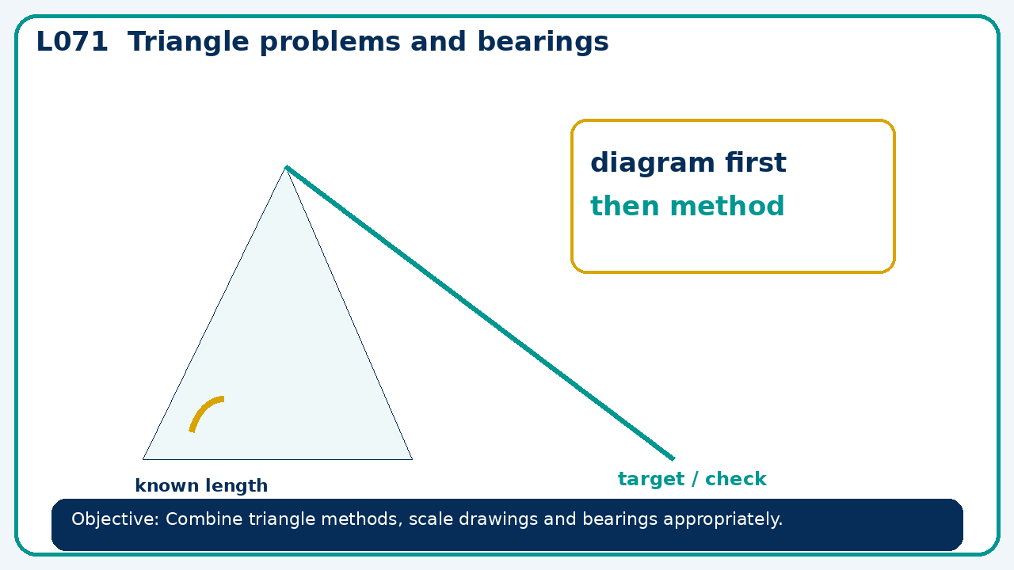

Core knowledge
- Foundation: right triangles and bearings.
- Higher: sine rule, cosine rule and non-right-triangle area

Method checklist
- Identify what the question is asking.
- Choose the relevant representation or method.
- Show working clearly and label units.
- Check the answer against the original context.
- Write one sentence explaining why the answer is reasonable.

Common error to avoid
- A bearing from A to B is 315°. State reverse bearing and explain the 180° change.

