
Reach for the Star | GCSE Mathematics 1MA1 | L071

Learner workbook: Triangle problems and bearings
Objective: Combine triangle methods, scale drawings and bearings appropriately.
Calculator condition: Non-calculator core; calculator optional only for checking where labelled.
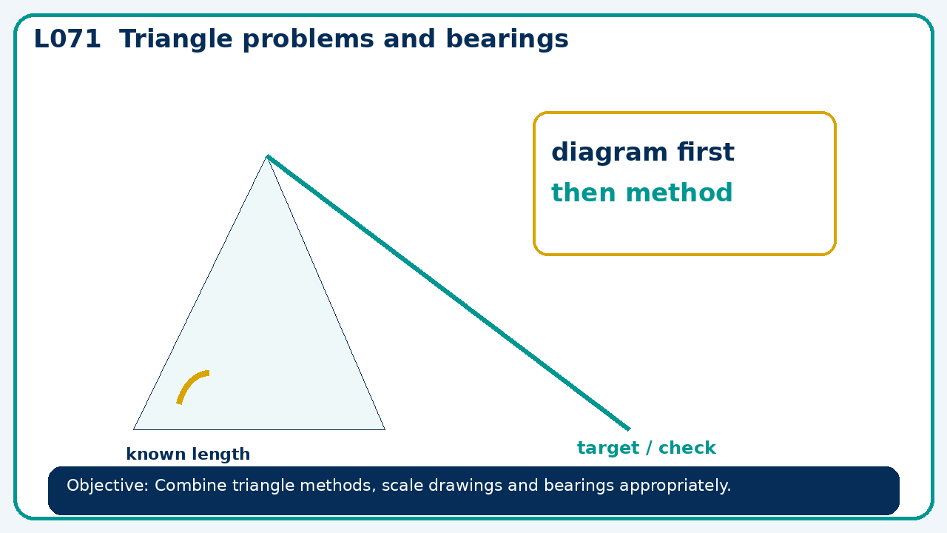

Connect & Check
- State the objective and timeline. Retrieve area and volume scale factors or a prerequisite. Diagnose a common error before modelling.
- Write one starting question you want answered today.

Choose your route
Route A: Visual  Use a diagram, graph, table or annotation first. | Route B: Method  Use a worked method, formula or calculation chain first. | Route C: Explain  Start with words: what is known, what is changing, and why.

Share
- Pairs compare methods or predict a result for triangle problems and bearings. Ask for a reason, not only an answer.

Present
- Foundation: right triangles and bearings.
- Higher: sine rule, cosine rule and non-right-triangle area

Apply: supported to independent
Recall: Retrieve the key fact or method needed for triangle problems and bearings.
Working: ______________________________________________________________
Check/explanation: ____________________________________________________
Core practice: A traveller goes north 12 km and east 5 km. Find distance and bearing from start to nearest degree.
Working: ______________________________________________________________
Check/explanation: ____________________________________________________
Reasoning: A bearing from A to B is 315°. State reverse bearing and explain the 180° change.
Working: ______________________________________________________________
Check/explanation: ____________________________________________________
Exam-style: Use a labelled diagram to calculate the missing value. State the theorem or formula and include units where needed.
Working: ______________________________________________________________
Check/explanation: ____________________________________________________

Recall & Review
- Revisit the objective. Learners solve a fresh item without prompts, explain a check, correct one error and record the next practice.
WWW: ________________________________ EBI: ________________________________

Recall & Review: feedback and extension integration
Lesson L071: Triangle problems and bearings
Objective: Combine triangle methods, scale drawings and bearings appropriately.
Timing for a 60-minute lesson
0-7 Connect & Check; 7-14 Share; 14-25 Present/model; 25-44 Apply route choice/practice; 44-52 independent exam-style check; 52-60 Recall & Review, WWW/EBI and next step.
Recall & Review evidence
At the end of the lesson, solve a fresh question without prompts, explain one check, correct one error and record the next practice step.
What Went Well (WWW)
I selected the correct geometric fact, theorem, formula or transformation and used a clear diagram with appropriate labels and units.
Even Better If (EBI)
I will name the fact or theorem, show the substitution or construction step and check whether the size, direction and units of the result are reasonable.
Integrated stretch and deep challenge
Stretch: A traveller goes north 12 km and east 5 km. Find distance and bearing from start to nearest degree.
Deep challenge: A bearing from A to B is 315°. State reverse bearing and explain the 180° change.
My next-step response

