
Reach for the Star | GCSE Mathematics 1MA1 | L072

Knowledge organiser: Cumulative checkpoint 5 and feedback
Objective: Choose and justify methods across earlier proportional and geometric work.
Calculator condition: Non-calculator core; calculator optional only for checking where labelled.
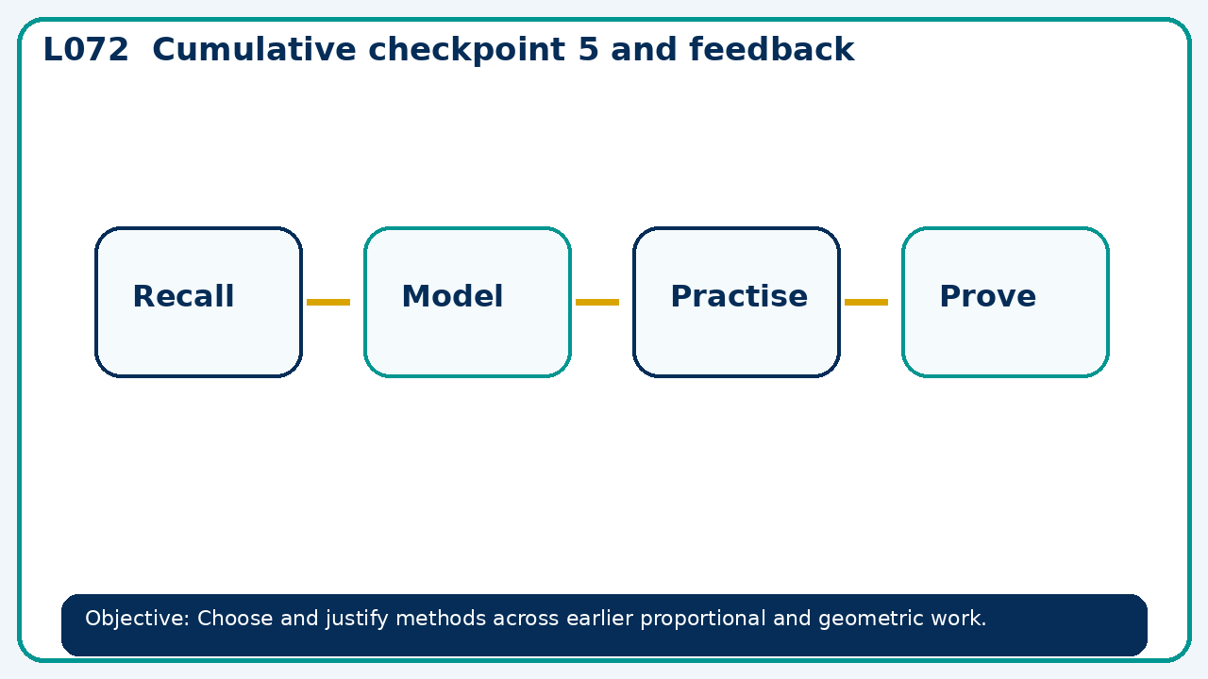

Core knowledge
- Assess cumulative learning; separate prerequisite gaps from method-selection errors

Method checklist
- Identify what the question is asking.
- Choose the relevant representation or method.
- Show working clearly and label units.
- Check the answer against the original context.
- Write one sentence explaining why the answer is reasonable.

Common error to avoid
- A learner uses a length factor of 3 to triple volume. Correct the claim.

