
Reach for the Star | GCSE Mathematics 1MA1 | L073

Knowledge organiser: Probability trees and combined events
Objective: Use probability trees and combine event probabilities.
Calculator condition: Non-calculator core; calculator optional only for checking where labelled.
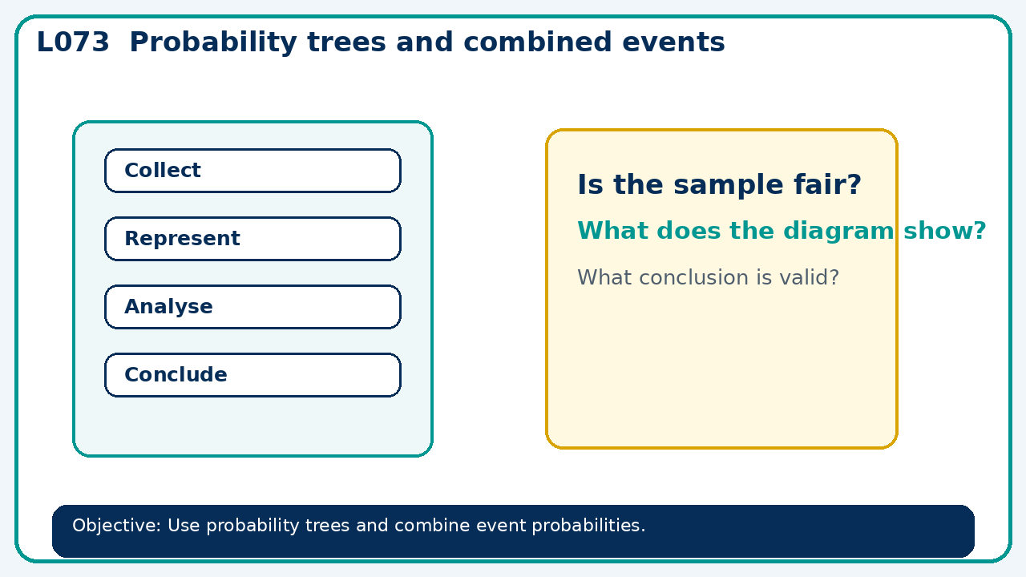

Core knowledge
- Label branches, check totals and identify whether to add or multiply

Method checklist
- Identify what the question is asking.
- Choose the relevant representation or method.
- Show working clearly and label units.
- Check the answer against the original context.
- Write one sentence explaining why the answer is reasonable.

Common error to avoid
- Toss a biased coin with P(H)=0.7 three times. Find P(exactly two heads).

