
Reach for the Star | GCSE Mathematics 1MA1 | L074

Knowledge organiser: Dependent events and assumptions
Objective: Recognise dependence and the assumptions behind a probability model.
Calculator condition: Non-calculator core; calculator optional only for checking where labelled.
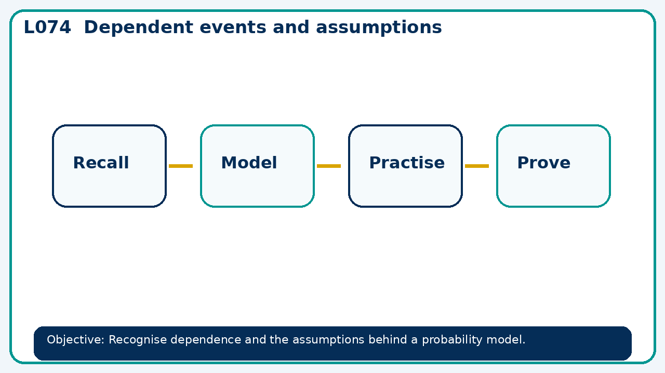

Core knowledge
- Foundation: simple experiments and frequency models.
- Higher: without-replacement trees and conditional probability

Method checklist
- Identify what the question is asking.
- Choose the relevant representation or method.
- Show working clearly and label units.
- Check the answer against the original context.
- Write one sentence explaining why the answer is reasonable.

Common error to avoid
- A bag has 4 red and 1 blue. Given the first draw was red, find P(second red without replacement).

