
Reach for the Star | GCSE Mathematics 1MA1 | L075

Knowledge organiser: Frequency trees and probability models
Objective: Interpret frequency trees and compare model predictions with observed data.
Calculator condition: Non-calculator core; calculator optional only for checking where labelled.
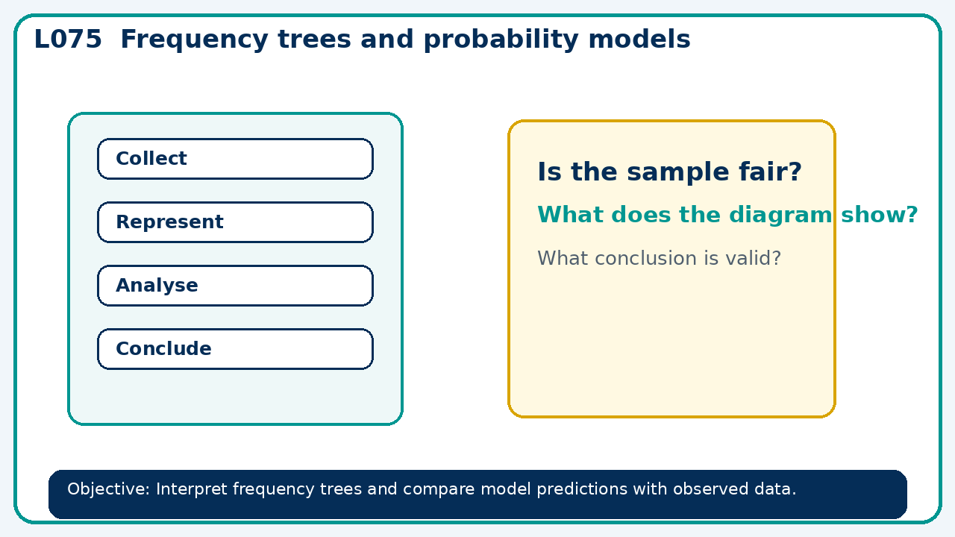

Core knowledge
- Move between counts and probabilities; distinguish experimental from theoretical probability

Method checklist
- Identify what the question is asking.
- Choose the relevant representation or method.
- Show working clearly and label units.
- Check the answer against the original context.
- Write one sentence explaining why the answer is reasonable.

Common error to avoid
- A frequency tree has root 60 and first branches 28 and 31. Diagnose the issue and state a possible repair.

