
Reach for the Star | GCSE Mathematics 1MA1 | L075

Learner workbook: Frequency trees and probability models
Objective: Interpret frequency trees and compare model predictions with observed data.
Calculator condition: Non-calculator core; calculator optional only for checking where labelled.
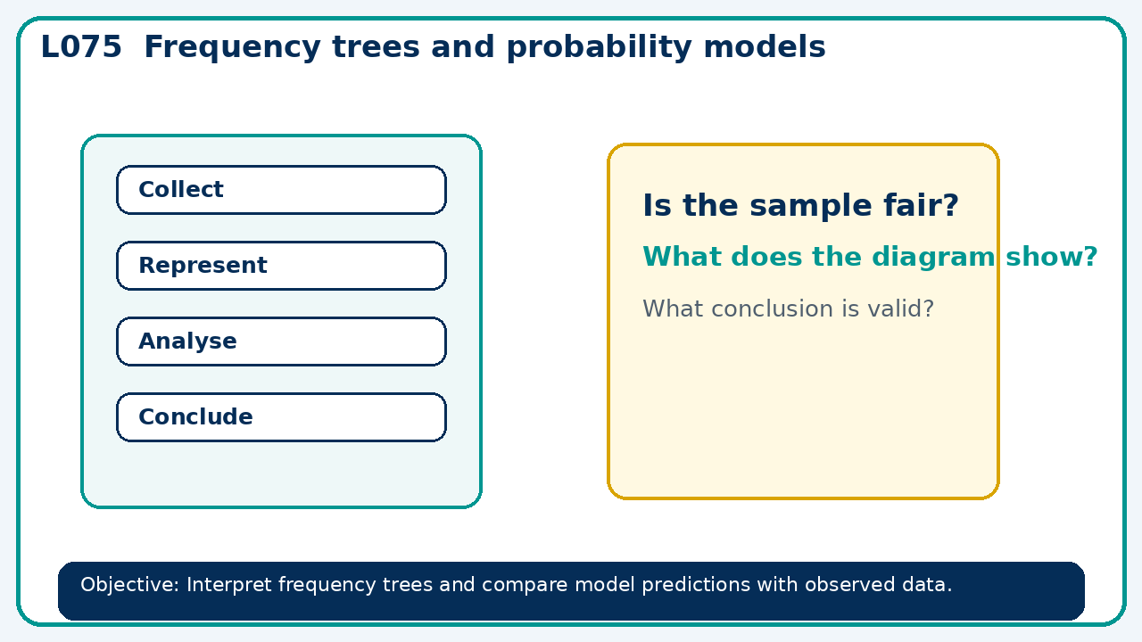

Connect & Check
- State the objective and timeline. Retrieve dependent events and assumptions or a prerequisite. Diagnose a common error before modelling.
- Write one starting question you want answered today.

Choose your route
Route A: Visual  Use a diagram, graph, table or annotation first. | Route B: Method  Use a worked method, formula or calculation chain first. | Route C: Explain  Start with words: what is known, what is changing, and why.

Share
- Pairs compare methods or predict a result for frequency trees and probability models. Ask for a reason, not only an answer.

Present
- Move between counts and probabilities; distinguish experimental from theoretical probability

Apply: supported to independent
Recall: Retrieve the key fact or method needed for frequency trees and probability models.
Working: ______________________________________________________________
Check/explanation: ____________________________________________________
Core practice: Of 80 people, 45 cycle. Of those who cycle, 27 are adults. Find the conditional proportion of adults among cyclists.
Working: ______________________________________________________________
Check/explanation: ____________________________________________________
Reasoning: A frequency tree has root 60 and first branches 28 and 31. Diagnose the issue and state a possible repair.
Working: ______________________________________________________________
Check/explanation: ____________________________________________________
Exam-style: A probability problem is presented with two stages. Complete the representation, calculate the probability and explain any assumption.
Working: ______________________________________________________________
Check/explanation: ____________________________________________________

Recall & Review
- Revisit the objective. Learners solve a fresh item without prompts, explain a check, correct one error and record the next practice.
WWW: ________________________________ EBI: ________________________________

Recall & Review: feedback and extension integration
Lesson L075: Frequency trees and probability models
Objective: Interpret frequency trees and compare model predictions with observed data.
Timing for a 60-minute lesson
0-7 Connect & Check; 7-14 Share; 14-25 Present/model; 25-44 Apply route choice/practice; 44-52 independent exam-style check; 52-60 Recall & Review, WWW/EBI and next step.
Recall & Review evidence
At the end of the lesson, solve a fresh question without prompts, explain one check, correct one error and record the next practice step.
What Went Well (WWW)
I represented the outcomes systematically, used the correct probability rule and checked that the probabilities or frequencies were consistent.
Even Better If (EBI)
I will show the sample space, branch or set reasoning explicitly, state any dependence or condition and check totals before giving the final probability.
Integrated stretch and deep challenge
Stretch: Of 80 people, 45 cycle. Of those who cycle, 27 are adults. Find the conditional proportion of adults among cyclists.
Deep challenge: A frequency tree has root 60 and first branches 28 and 31. Diagnose the issue and state a possible repair.
My next-step response

