
Reach for the Star | GCSE Mathematics 1MA1 | L076

Knowledge organiser: Probability pathway and repair
Objective: Select a probability representation and repair common errors.
Calculator condition: Non-calculator core; calculator optional only for checking where labelled.
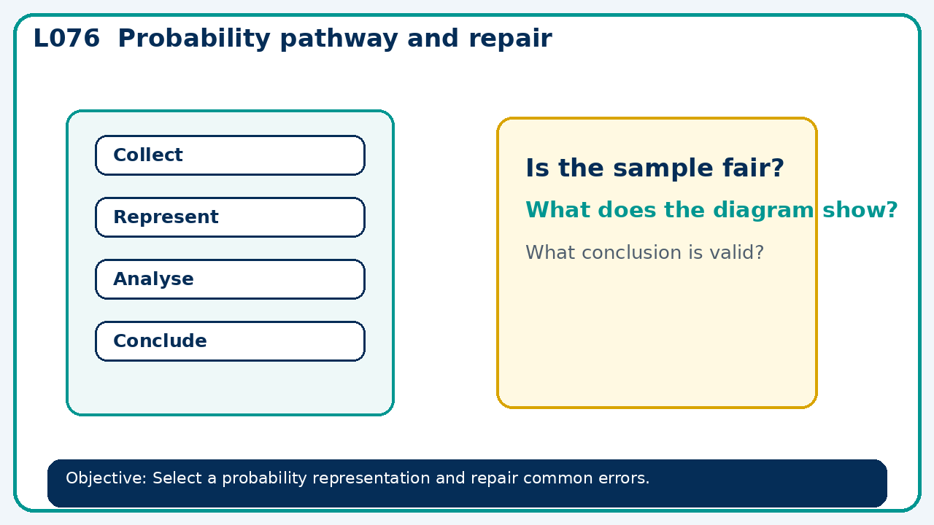

Core knowledge
- Foundation: sample spaces and frequency trees.
- Higher: conditional and dependent events

Method checklist
- Identify what the question is asking.
- Choose the relevant representation or method.
- Show working clearly and label units.
- Check the answer against the original context.
- Write one sentence explaining why the answer is reasonable.

Common error to avoid
- A bag with 3 red and 2 blue is drawn twice without replacement. Are the events independent? Show with probabilities.

