
Reach for the Star | GCSE Mathematics 1MA1 | L077

Knowledge organiser: Scatter graphs and correlation
Objective: Describe correlation, use a line of best fit and recognise limits of prediction.
Calculator condition: Calculator allowed where labelled; non-calculator reasoning remains required.
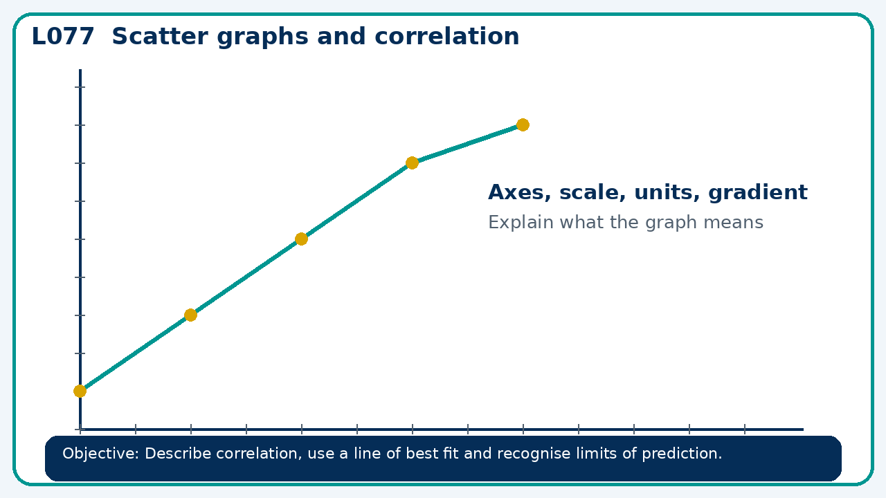

Core knowledge
- Distinguish association from cause; contrast interpolation and extrapolation

Method checklist
- Identify what the question is asking.
- Choose the relevant representation or method.
- Show working clearly and label units.
- Check the answer against the original context.
- Write one sentence explaining why the answer is reasonable.

Common error to avoid
- A scatter graph shows strong negative correlation between screen time and sleep. Can it prove screen time causes less sleep?

