
Reach for the Star | GCSE Mathematics 1MA1 | L077

Learner workbook: Scatter graphs and correlation
Objective: Describe correlation, use a line of best fit and recognise limits of prediction.
Calculator condition: Calculator allowed where labelled; non-calculator reasoning remains required.
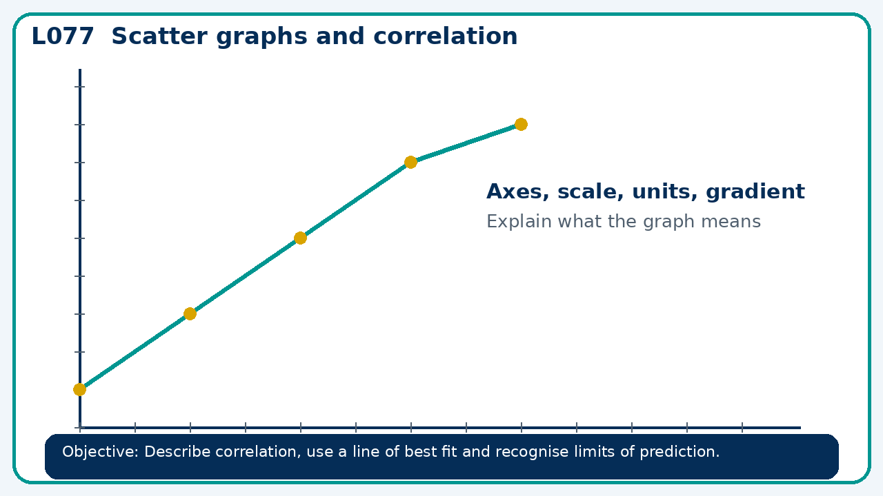

Connect & Check
- State the objective and timeline. Retrieve probability pathway and repair or a prerequisite. Diagnose a common error before modelling.
- Write one starting question you want answered today.

Choose your route
Route A: Visual  Use a diagram, graph, table or annotation first. | Route B: Method  Use a worked method, formula or calculation chain first. | Route C: Explain  Start with words: what is known, what is changing, and why.

Share
- Pairs compare methods or predict a result for scatter graphs and correlation. Ask for a reason, not only an answer.

Present
- Distinguish association from cause; contrast interpolation and extrapolation

Apply: supported to independent
Recall: Retrieve the key fact or method needed for scatter graphs and correlation.
Working: ______________________________________________________________
Check/explanation: ____________________________________________________
Core practice: A trend line predicts 45 at x=8 from data spanning x=2 to 10. Is this interpolation or extrapolation?
Working: ______________________________________________________________
Check/explanation: ____________________________________________________
Reasoning: A scatter graph shows strong negative correlation between screen time and sleep. Can it prove screen time causes less sleep?
Working: ______________________________________________________________
Check/explanation: ____________________________________________________
Exam-style: A graph is drawn for a real context. Interpret the gradient, intercept or area as appropriate. State units and justify your answer.
Working: ______________________________________________________________
Check/explanation: ____________________________________________________

Recall & Review
- Revisit the objective. Learners solve a fresh item without prompts, explain a check, correct one error and record the next practice.
WWW: ________________________________ EBI: ________________________________

Recall & Review: feedback and extension integration
Lesson L077: Scatter graphs and correlation
Objective: Describe correlation, use a line of best fit and recognise limits of prediction.
Timing for a 60-minute lesson
0-7 Connect & Check; 7-14 Share; 14-25 Present/model; 25-44 Apply route choice/practice; 44-52 independent exam-style check; 52-60 Recall & Review, WWW/EBI and next step.
Recall & Review evidence
At the end of the lesson, solve a fresh question without prompts, explain one check, correct one error and record the next practice step.
What Went Well (WWW)
I read or constructed the graph accurately, used the scale and axes correctly and linked the relevant gradient, intercept, shape or trend to my conclusion.
Even Better If (EBI)
I will label units and scale clearly, show the calculation or graphical evidence I used and check that the interpretation fits the context.
Integrated stretch and deep challenge
Stretch: A trend line predicts 45 at x=8 from data spanning x=2 to 10. Is this interpolation or extrapolation?
Deep challenge: A scatter graph shows strong negative correlation between screen time and sleep. Can it prove screen time causes less sleep?
My next-step response

