
Reach for the Star | GCSE Mathematics 1MA1 | L078

Knowledge organiser: Statistical graphs pathway
Objective: Select and interpret statistical graphs appropriate to the tier.
Calculator condition: Calculator allowed where labelled; non-calculator reasoning remains required.
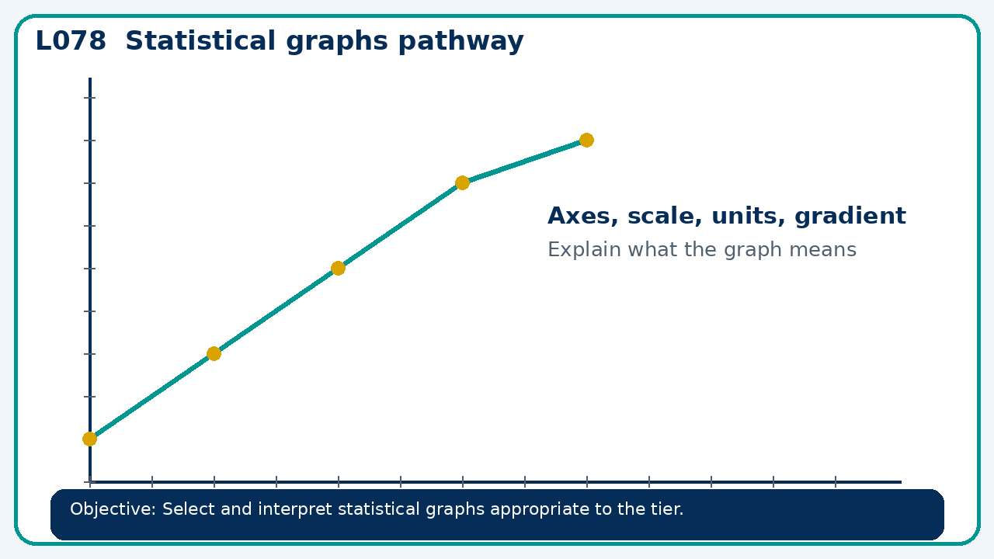

Core knowledge
- Foundation: charts and grouped summaries.
- Higher: cumulative frequency and histograms with unequal intervals

Method checklist
- Identify what the question is asking.
- Choose the relevant representation or method.
- Show working clearly and label units.
- Check the answer against the original context.
- Write one sentence explaining why the answer is reasonable.

Common error to avoid
- Why must a histogram use area rather than bar height for frequency when widths differ?

