
Reach for the Star | GCSE Mathematics 1MA1 | L079

Knowledge organiser: Comparing distributions pathway
Objective: Compare distributions using suitable statistics and graphical evidence.
Calculator condition: Non-calculator core; calculator optional only for checking where labelled.
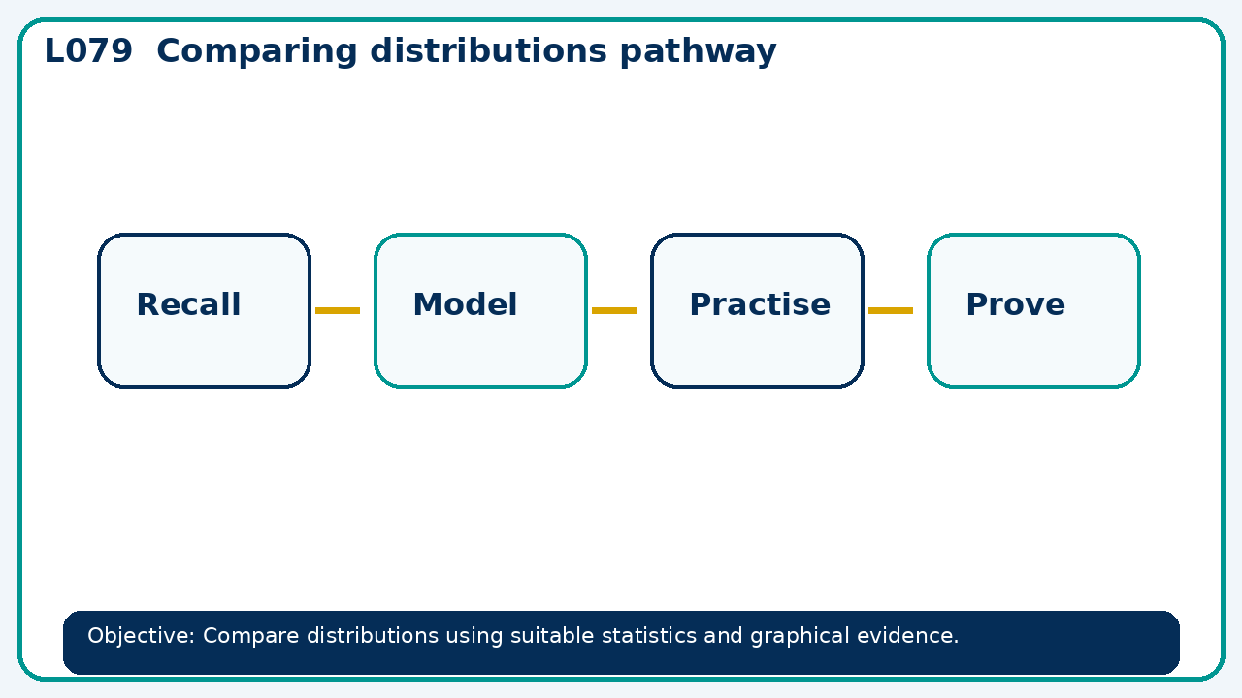

Core knowledge
- Foundation: mean, median and range.
- Higher: quartiles, interquartile range and box plots

Method checklist
- Identify what the question is asking.
- Choose the relevant representation or method.
- Show working clearly and label units.
- Check the answer against the original context.
- Write one sentence explaining why the answer is reasonable.

Common error to avoid
- Can one distribution have both a higher median and a larger IQR than another? Explain the practical interpretation.

