
Reach for the Star | GCSE Mathematics 1MA1 | L080

Knowledge organiser: Cumulative checkpoint 6 and feedback
Objective: Apply probability and statistics with earlier number and algebra.
Calculator condition: Non-calculator core; calculator optional only for checking where labelled.
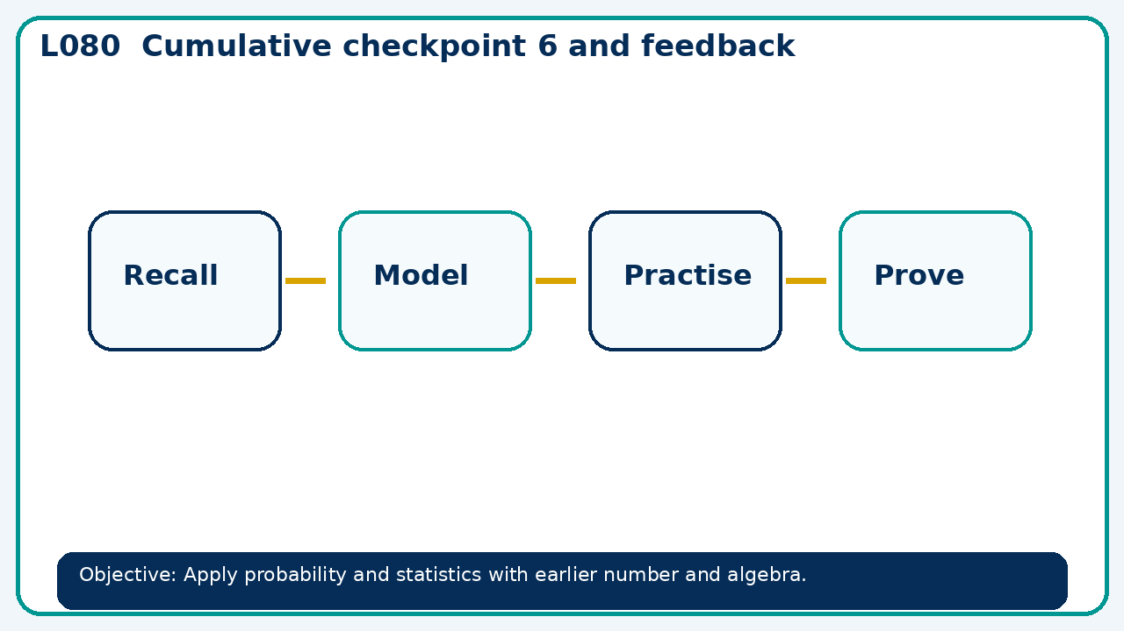

Core knowledge
- Use a cumulative diagnostic followed by targeted repair and a fresh check

Method checklist
- Identify what the question is asking.
- Choose the relevant representation or method.
- Show working clearly and label units.
- Check the answer against the original context.
- Write one sentence explaining why the answer is reasonable.

Common error to avoid
- Explain why a single experimental probability estimate may change when more trials are added.

