
Reach for the Star | GCSE Mathematics 1MA1 | L081

Knowledge organiser: Circle geometry pathway
Objective: Use circle geometry at the appropriate tier and explain angle reasoning.
Calculator condition: Non-calculator core; calculator optional only for checking where labelled.
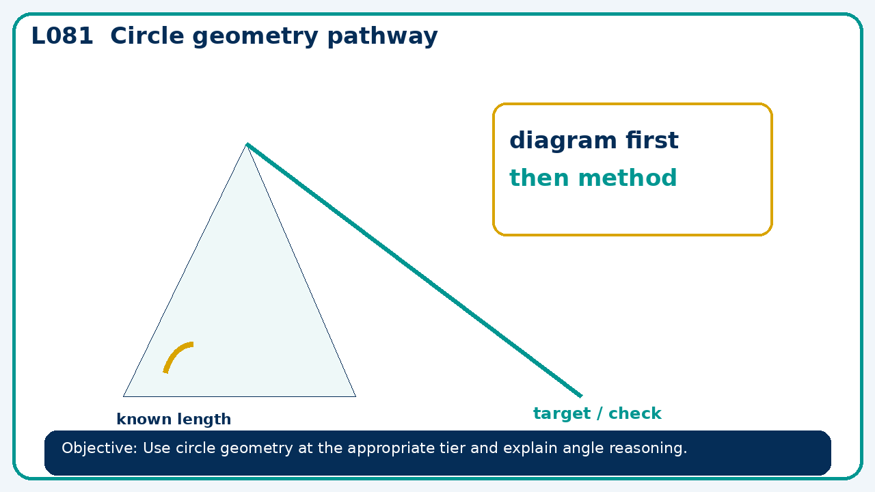

Core knowledge
- Foundation: circle measures and general angle facts.
- Higher: circle theorems and proof chains

Method checklist
- Identify what the question is asking.
- Choose the relevant representation or method.
- Show working clearly and label units.
- Check the answer against the original context.
- Write one sentence explaining why the answer is reasonable.

Common error to avoid
- In a cyclic quadrilateral, opposite angles are 2x+10 and 3x−5. Find x and both angles.

