
Reach for the Star | GCSE Mathematics 1MA1 | L081

Learner workbook: Circle geometry pathway
Objective: Use circle geometry at the appropriate tier and explain angle reasoning.
Calculator condition: Non-calculator core; calculator optional only for checking where labelled.
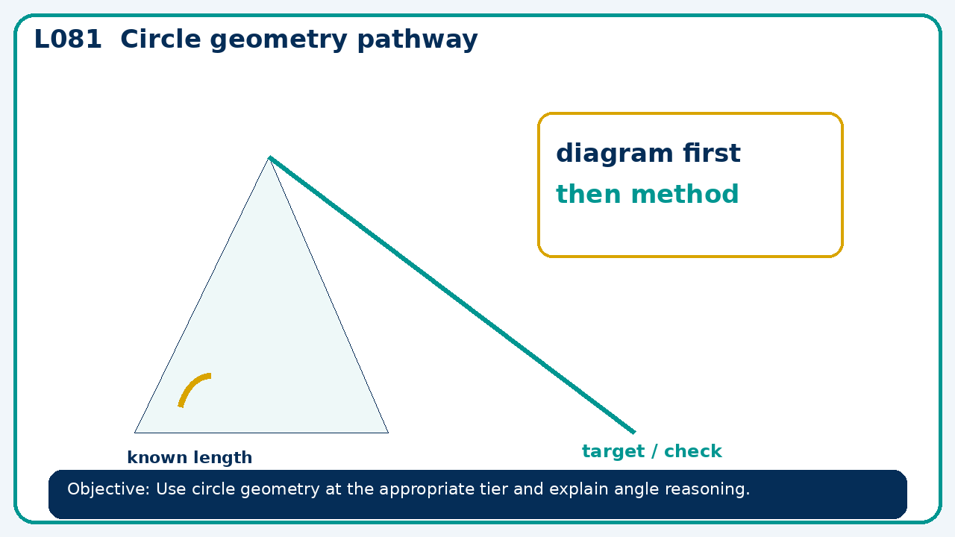

Connect & Check
- State the objective and timeline. Retrieve cumulative checkpoint 6 and feedback or a prerequisite. Diagnose a common error before modelling.
- Write one starting question you want answered today.

Choose your route
Route A: Visual  Use a diagram, graph, table or annotation first. | Route B: Method  Use a worked method, formula or calculation chain first. | Route C: Explain  Start with words: what is known, what is changing, and why.

Share
- Pairs compare methods or predict a result for circle geometry pathway. Ask for a reason, not only an answer.

Present
- Foundation: circle measures and general angle facts.
- Higher: circle theorems and proof chains

Apply: supported to independent
Recall: Retrieve the key fact or method needed for circle geometry pathway.
Working: ______________________________________________________________
Check/explanation: ____________________________________________________
Core practice: A central angle is 146°. Find the circumference angle subtending the same arc.
Working: ______________________________________________________________
Check/explanation: ____________________________________________________
Reasoning: In a cyclic quadrilateral, opposite angles are 2x+10 and 3x−5. Find x and both angles.
Working: ______________________________________________________________
Check/explanation: ____________________________________________________
Exam-style: Use a labelled diagram to calculate the missing value. State the theorem or formula and include units where needed.
Working: ______________________________________________________________
Check/explanation: ____________________________________________________

Recall & Review
- Revisit the objective. Learners solve a fresh item without prompts, explain a check, correct one error and record the next practice.
WWW: ________________________________ EBI: ________________________________

Recall & Review: feedback and extension integration
Lesson L081: Circle geometry pathway
Objective: Use circle geometry at the appropriate tier and explain angle reasoning.
Timing for a 60-minute lesson
0-7 Connect & Check; 7-14 Share; 14-25 Present/model; 25-44 Apply route choice/practice; 44-52 independent exam-style check; 52-60 Recall & Review, WWW/EBI and next step.
Recall & Review evidence
At the end of the lesson, solve a fresh question without prompts, explain one check, correct one error and record the next practice step.
What Went Well (WWW)
I selected the correct geometric fact, theorem, formula or transformation and used a clear diagram with appropriate labels and units.
Even Better If (EBI)
I will name the fact or theorem, show the substitution or construction step and check whether the size, direction and units of the result are reasonable.
Integrated stretch and deep challenge
Stretch: A central angle is 146°. Find the circumference angle subtending the same arc.
Deep challenge: In a cyclic quadrilateral, opposite angles are 2x+10 and 3x−5. Find x and both angles.
My next-step response

