
Reach for the Star | GCSE Mathematics 1MA1 | L082

Knowledge organiser: Vectors and translations
Objective: Represent translations as column vectors and combine displacements.
Calculator condition: Non-calculator core; calculator optional only for checking where labelled.
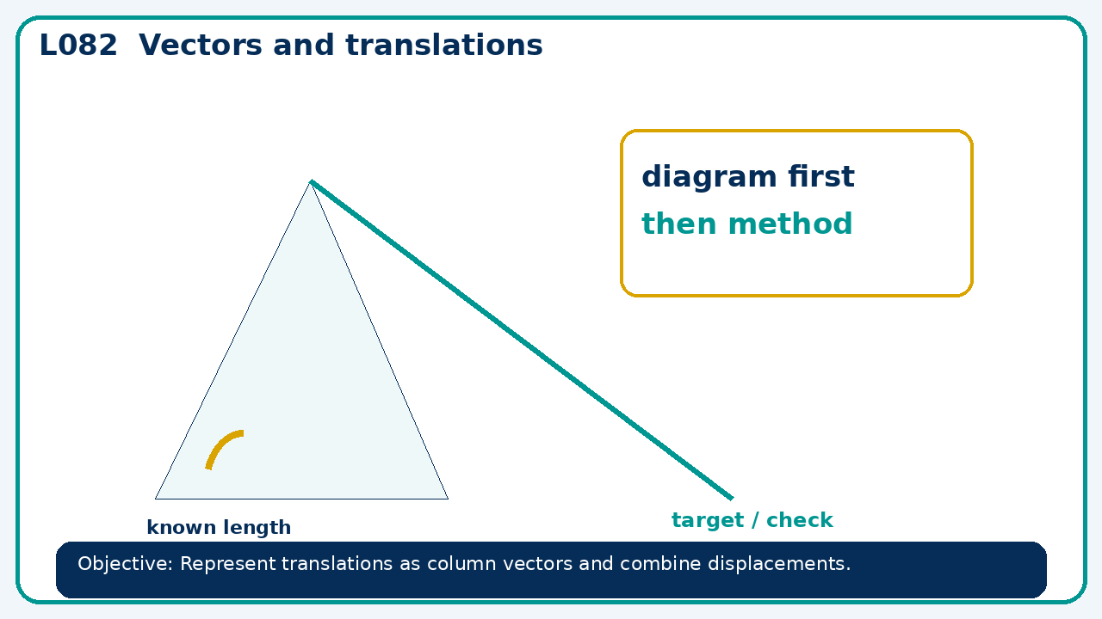

Core knowledge
- Connect arrows and coordinates; distinguish a position from a displacement

Method checklist
- Identify what the question is asking.
- Choose the relevant representation or method.
- Show working clearly and label units.
- Check the answer against the original context.
- Write one sentence explaining why the answer is reasonable.

Common error to avoid
- A translation maps A=(−2,5) to A'=(4,−1). Show where B=(3,3) maps.

