
Reach for the Star | GCSE Mathematics 1MA1 | L083

Knowledge organiser: Vector reasoning pathway
Objective: Reason with vectors at the appropriate tier.
Calculator condition: Non-calculator core; calculator optional only for checking where labelled.
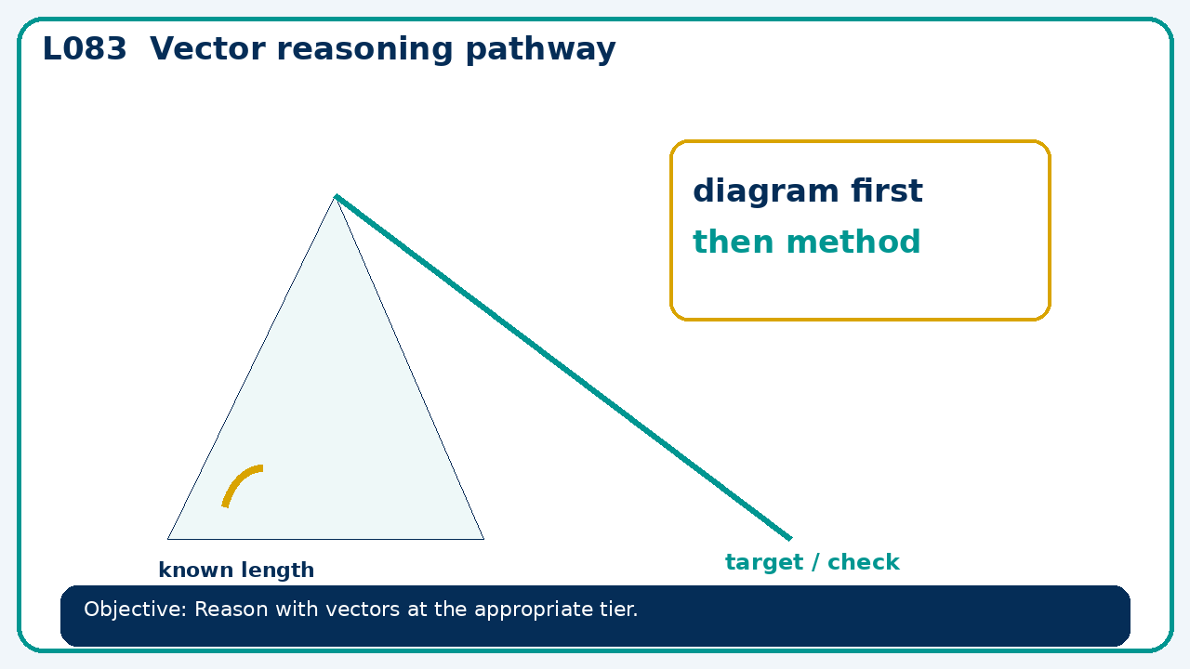

Core knowledge
- Foundation: translations and vector arithmetic.
- Higher: geometric vector arguments, parallelism and division of lines

Method checklist
- Identify what the question is asking.
- Choose the relevant representation or method.
- Show working clearly and label units.
- Check the answer against the original context.
- Write one sentence explaining why the answer is reasonable.

Common error to avoid
- Prove vector AB+BC=AC for A=(1,1),B=(4,3),C=(7,−2).

