
Reach for the Star | GCSE Mathematics 1MA1 | L083

Learner workbook: Vector reasoning pathway
Objective: Reason with vectors at the appropriate tier.
Calculator condition: Non-calculator core; calculator optional only for checking where labelled.
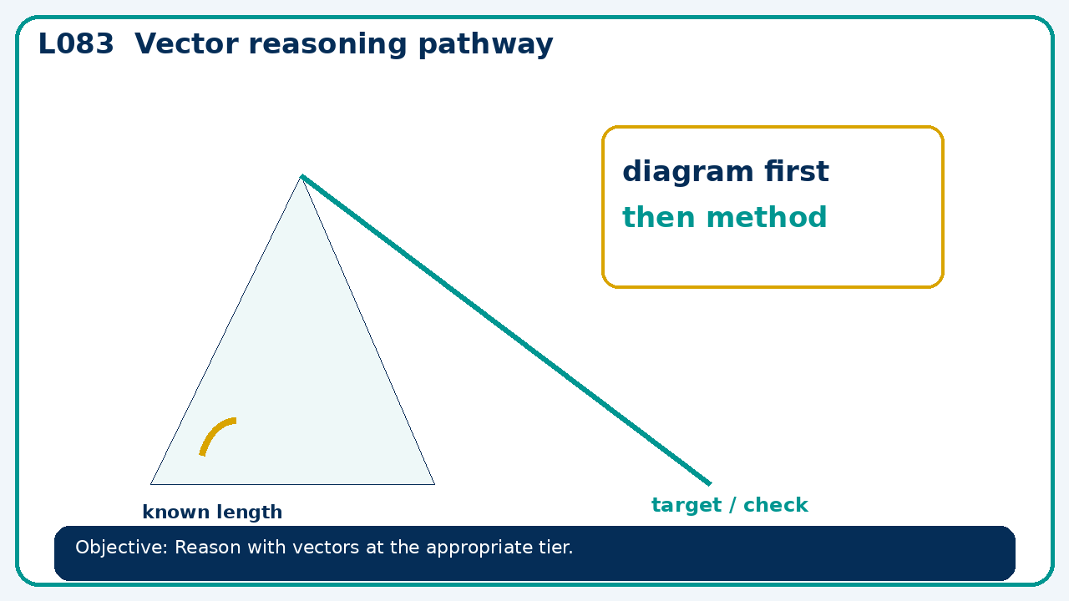

Connect & Check
- State the objective and timeline. Retrieve vectors and translations or a prerequisite. Diagnose a common error before modelling.
- Write one starting question you want answered today.

Choose your route
Route A: Visual  Use a diagram, graph, table or annotation first. | Route B: Method  Use a worked method, formula or calculation chain first. | Route C: Explain  Start with words: what is known, what is changing, and why.

Share
- Pairs compare methods or predict a result for vector reasoning pathway. Ask for a reason, not only an answer.

Present
- Foundation: translations and vector arithmetic.
- Higher: geometric vector arguments, parallelism and division of lines

Apply: supported to independent
Recall: Retrieve the key fact or method needed for vector reasoning pathway.
Working: ______________________________________________________________
Check/explanation: ____________________________________________________
Core practice: If a=(4,−1) and b=(−2,5), find 3a+2b.
Working: ______________________________________________________________
Check/explanation: ____________________________________________________
Reasoning: Prove vector AB+BC=AC for A=(1,1),B=(4,3),C=(7,−2).
Working: ______________________________________________________________
Check/explanation: ____________________________________________________
Exam-style: Solve an exam-style problem involving vector reasoning pathway. Show working, include a check and interpret your answer.
Working: ______________________________________________________________
Check/explanation: ____________________________________________________

Recall & Review
- Revisit the objective. Learners solve a fresh item without prompts, explain a check, correct one error and record the next practice.
WWW: ________________________________ EBI: ________________________________

Recall & Review: feedback and extension integration
Lesson L083: Vector reasoning pathway
Objective: Reason with vectors at the appropriate tier.
Timing for a 60-minute lesson
0-7 Connect & Check; 7-14 Share; 14-25 Present/model; 25-44 Apply route choice/practice; 44-52 independent exam-style check; 52-60 Recall & Review, WWW/EBI and next step.
Recall & Review evidence
At the end of the lesson, solve a fresh question without prompts, explain one check, correct one error and record the next practice step.
What Went Well (WWW)
I selected the correct geometric fact, theorem, formula or transformation and used a clear diagram with appropriate labels and units.
Even Better If (EBI)
I will name the fact or theorem, show the substitution or construction step and check whether the size, direction and units of the result are reasonable.
Integrated stretch and deep challenge
Stretch: If a=(4,−1) and b=(−2,5), find 3a+2b.
Deep challenge: Prove vector AB+BC=AC for A=(1,1),B=(4,3),C=(7,−2).
My next-step response

