
Reach for the Star | GCSE Mathematics 1MA1 | L084

Knowledge organiser: Geometry connections and repair
Objective: Connect geometry methods and repair weaknesses revealed by evidence.
Calculator condition: Non-calculator core; calculator optional only for checking where labelled.
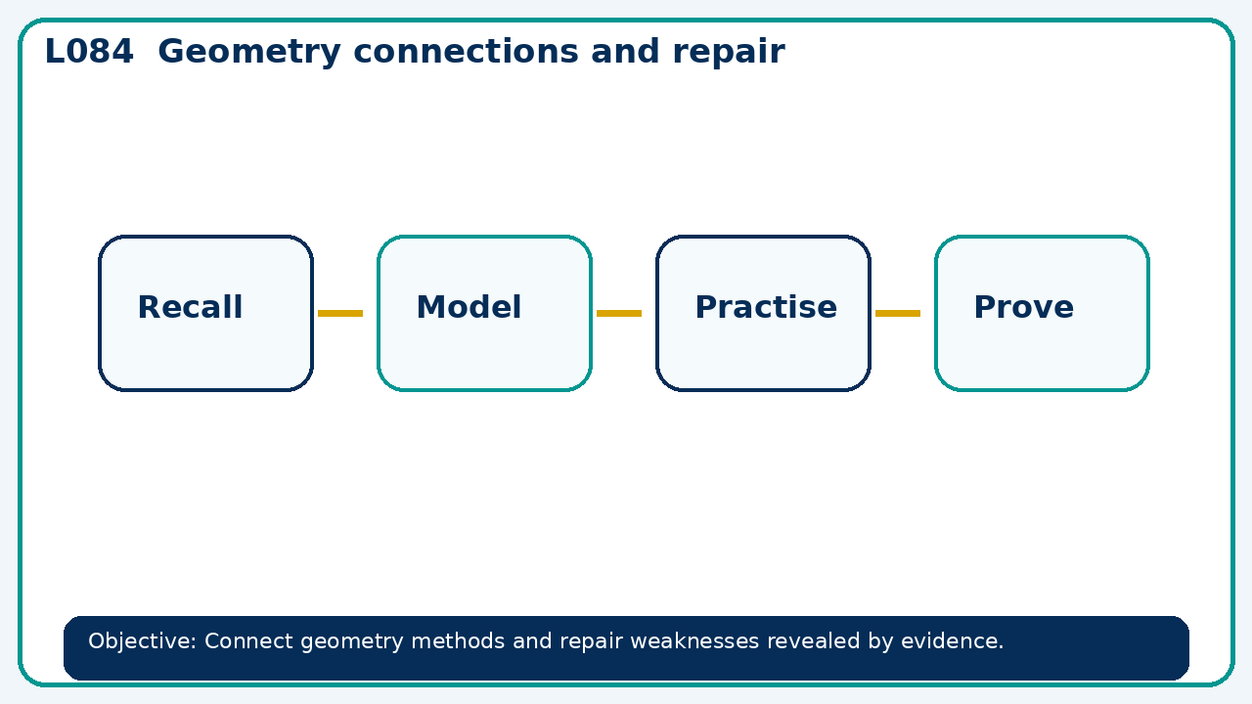

Core knowledge
- Contrast a diagram's appearance with given facts; choose angle, length or vector methods

Method checklist
- Identify what the question is asking.
- Choose the relevant representation or method.
- Show working clearly and label units.
- Check the answer against the original context.
- Write one sentence explaining why the answer is reasonable.

Common error to avoid
- A translated quadrilateral keeps all side lengths. Explain why translation also preserves parallel sides.

