
Reach for the Star | GCSE Mathematics 1MA1 | L085

Knowledge organiser: Functions pathway
Objective: Interpret functions at the appropriate tier.
Calculator condition: Non-calculator core; calculator optional only for checking where labelled.
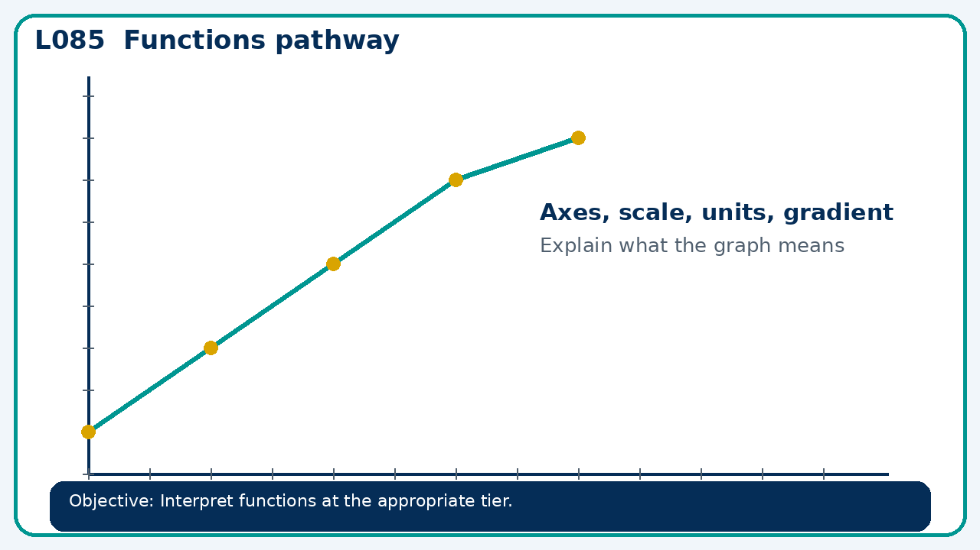

Core knowledge
- Foundation: function machines and substitution.
- Higher: function notation, inverse and composite functions

Method checklist
- Identify what the question is asking.
- Choose the relevant representation or method.
- Show working clearly and label units.
- Check the answer against the original context.
- Write one sentence explaining why the answer is reasonable.

Common error to avoid
- Let f(x)=2x+1 and g(x)=x². Compare f(g(3)) and g(f(3)).

