
Reach for the Star | GCSE Mathematics 1MA1 | L086

Knowledge organiser: Graph transformations pathway
Objective: Interpret changes to graphs at the appropriate tier.
Calculator condition: Calculator allowed where labelled; non-calculator reasoning remains required.
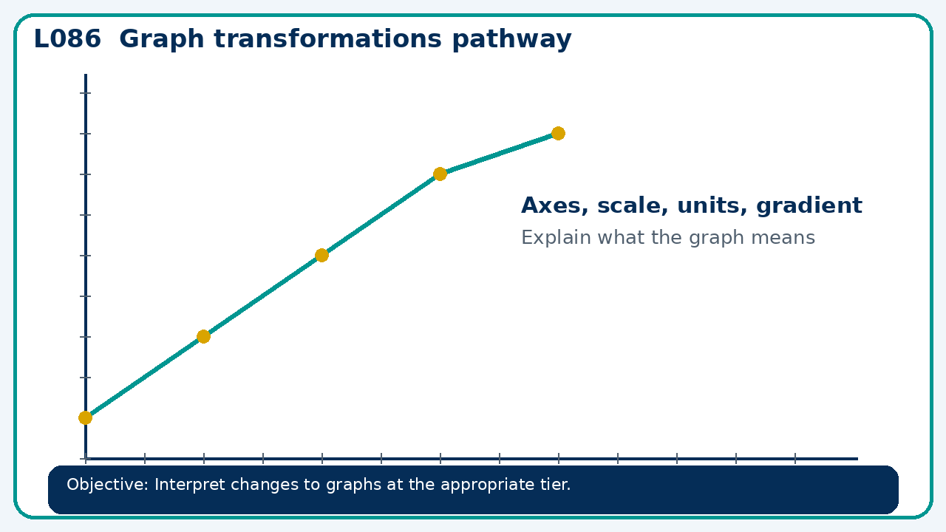

Core knowledge
- Foundation: coordinates and straight-line changes.
- Higher: translations and reflections of function graphs

Method checklist
- Identify what the question is asking.
- Choose the relevant representation or method.
- Show working clearly and label units.
- Check the answer against the original context.
- Write one sentence explaining why the answer is reasonable.

Common error to avoid
- A learner says y=(x−4)² moves left 4. Correct using a point on the original graph.

