
Reach for the Star | GCSE Mathematics 1MA1 | L086

Learner workbook: Graph transformations pathway
Objective: Interpret changes to graphs at the appropriate tier.
Calculator condition: Calculator allowed where labelled; non-calculator reasoning remains required.
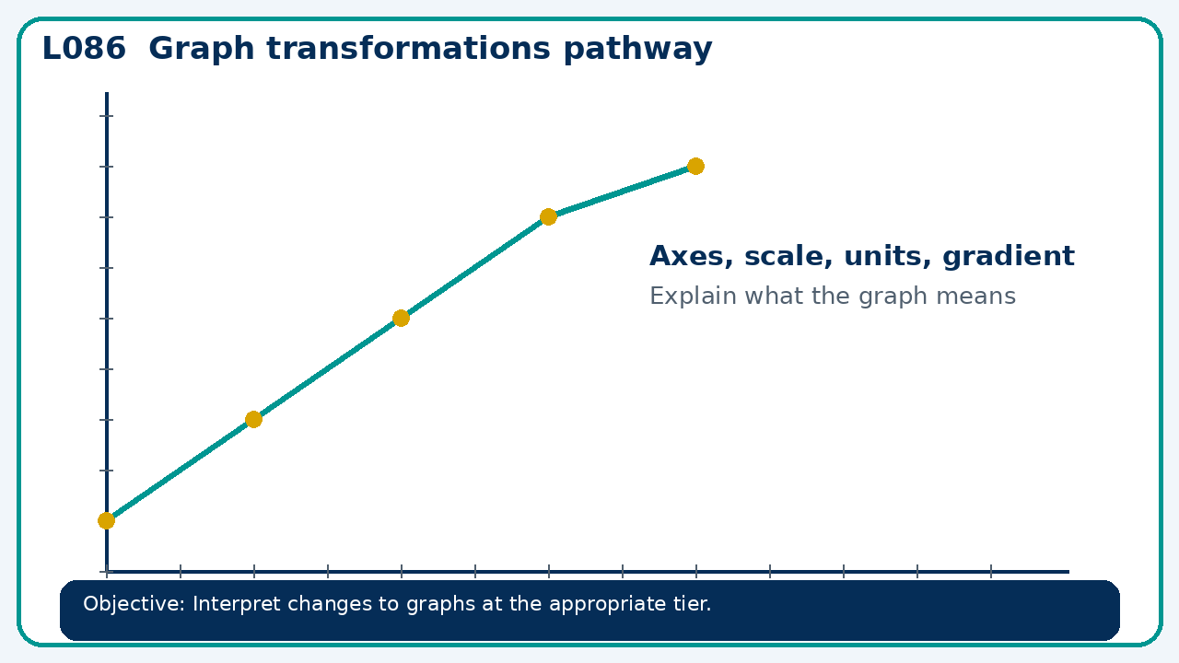

Connect & Check
- State the objective and timeline. Retrieve functions pathway or a prerequisite. Diagnose a common error before modelling.
- Write one starting question you want answered today.

Choose your route
Route A: Visual  Use a diagram, graph, table or annotation first. | Route B: Method  Use a worked method, formula or calculation chain first. | Route C: Explain  Start with words: what is known, what is changing, and why.

Share
- Pairs compare methods or predict a result for graph transformations pathway. Ask for a reason, not only an answer.

Present
- Foundation: coordinates and straight-line changes.
- Higher: translations and reflections of function graphs

Apply: supported to independent
Recall: Retrieve the key fact or method needed for graph transformations pathway.
Working: ______________________________________________________________
Check/explanation: ____________________________________________________
Core practice: Describe transformations from y=x² to y=(x+3)²+2 and state turning point.
Working: ______________________________________________________________
Check/explanation: ____________________________________________________
Reasoning: A learner says y=(x−4)² moves left 4. Correct using a point on the original graph.
Working: ______________________________________________________________
Check/explanation: ____________________________________________________
Exam-style: A graph is drawn for a real context. Interpret the gradient, intercept or area as appropriate. State units and justify your answer.
Working: ______________________________________________________________
Check/explanation: ____________________________________________________

Recall & Review
- Revisit the objective. Learners solve a fresh item without prompts, explain a check, correct one error and record the next practice.
WWW: ________________________________ EBI: ________________________________

Recall & Review: feedback and extension integration
Lesson L086: Graph transformations pathway
Objective: Interpret changes to graphs at the appropriate tier.
Timing for a 60-minute lesson
0-7 Connect & Check; 7-14 Share; 14-25 Present/model; 25-44 Apply route choice/practice; 44-52 independent exam-style check; 52-60 Recall & Review, WWW/EBI and next step.
Recall & Review evidence
At the end of the lesson, solve a fresh question without prompts, explain one check, correct one error and record the next practice step.
What Went Well (WWW)
I read or constructed the graph accurately, used the scale and axes correctly and linked the relevant gradient, intercept, shape or trend to my conclusion.
Even Better If (EBI)
I will label units and scale clearly, show the calculation or graphical evidence I used and check that the interpretation fits the context.
Integrated stretch and deep challenge
Stretch: Describe transformations from y=x² to y=(x+3)²+2 and state turning point.
Deep challenge: A learner says y=(x−4)² moves left 4. Correct using a point on the original graph.
My next-step response

