
Reach for the Star | GCSE Mathematics 1MA1 | L087

Knowledge organiser: Equation-solving pathway
Objective: Select equation and inequality methods appropriate to the tier.
Calculator condition: Non-calculator core; calculator optional only for checking where labelled.
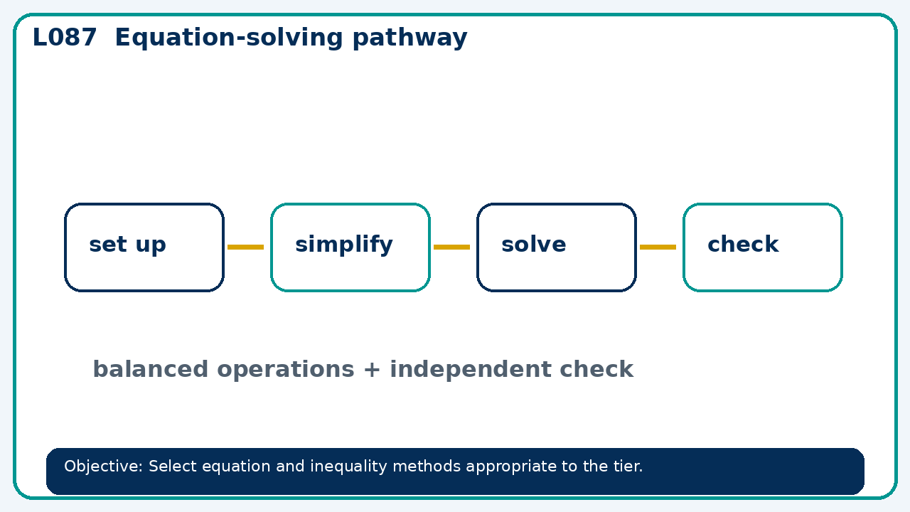

Core knowledge
- Foundation: linear equations and number-line inequalities.
- Higher: iteration, quadratic inequalities and regions

Method checklist
- Identify what the question is asking.
- Choose the relevant representation or method.
- Show working clearly and label units.
- Check the answer against the original context.
- Write one sentence explaining why the answer is reasonable.

Common error to avoid
- Solve x+y=11 and 2x−y=4, then show both checks.

