
Reach for the Star | GCSE Mathematics 1MA1 | L088

Knowledge organiser: Cumulative checkpoint 7 and feedback
Objective: Apply algebra and geometry pathways in a cumulative assessment.
Calculator condition: Non-calculator core; calculator optional only for checking where labelled.
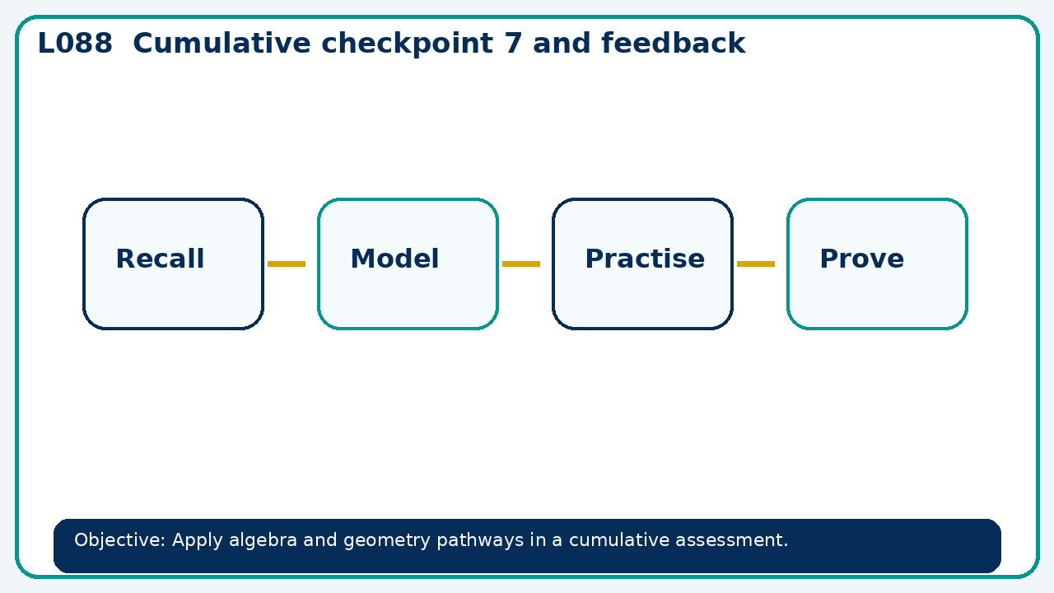

Core knowledge
- Use errors to select a prerequisite, model a repair and reassess independently

Method checklist
- Identify what the question is asking.
- Choose the relevant representation or method.
- Show working clearly and label units.
- Check the answer against the original context.
- Write one sentence explaining why the answer is reasonable.

Common error to avoid
- Why is substituting a found root back into the original equations stronger than repeating the same algebra?

