
Reach for the Star | GCSE Mathematics 1MA1 | L089

Knowledge organiser: Rates from graphs pathway
Objective: Interpret rates and areas from graphs at the appropriate tier.
Calculator condition: Calculator allowed where labelled; non-calculator reasoning remains required.
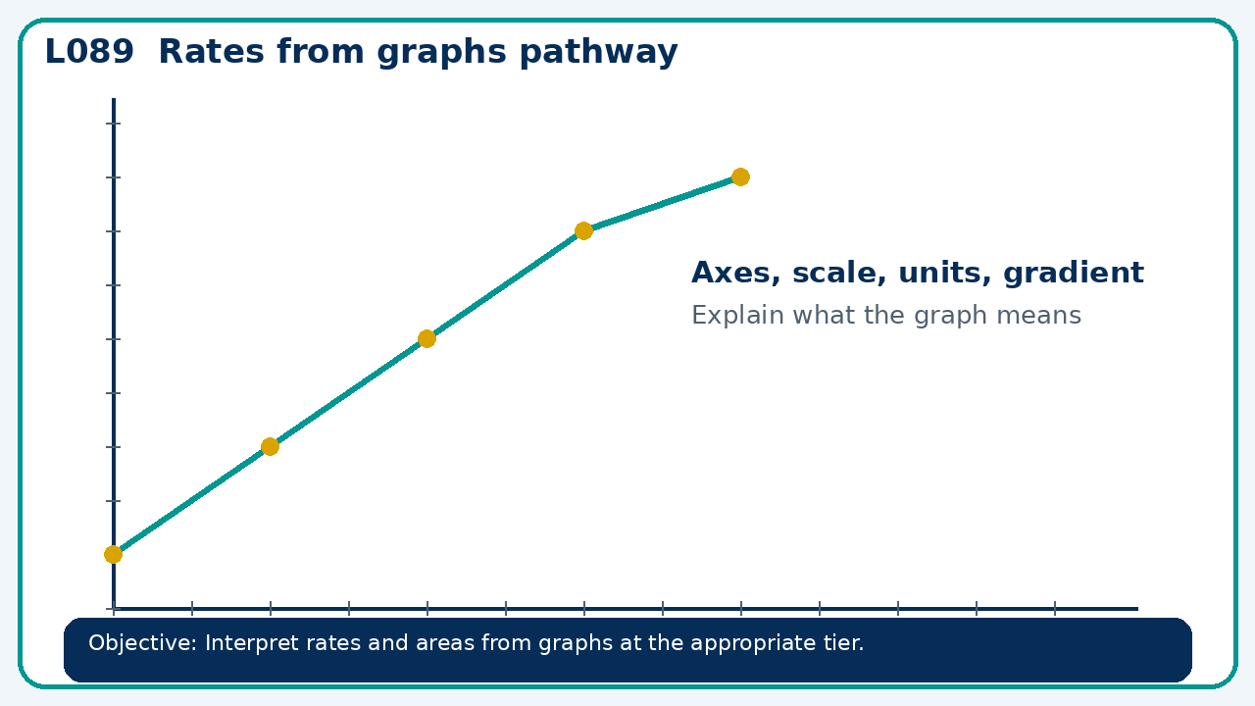

Core knowledge
- Foundation: straight-line rates and simple speed graphs.
- Higher: tangents and estimates of area under curves

Method checklist
- Identify what the question is asking.
- Choose the relevant representation or method.
- Show working clearly and label units.
- Check the answer against the original context.
- Write one sentence explaining why the answer is reasonable.

Common error to avoid
- A velocity-time graph dips below the time axis. What does negative area mean?

