
Reach for the Star | GCSE Mathematics 1MA1 | L090

Knowledge organiser: Circle equations pathway
Objective: Connect circle and coordinate geometry at the appropriate tier.
Calculator condition: Non-calculator core; calculator optional only for checking where labelled.
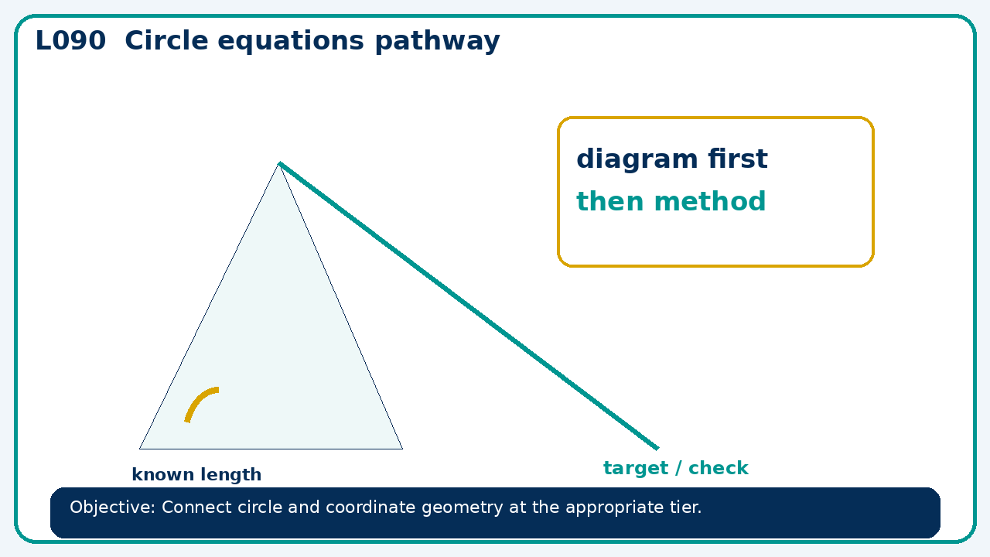

Core knowledge
- Foundation: coordinates and circle measures.
- Higher: circle equations and tangent reasoning

Method checklist
- Identify what the question is asking.
- Choose the relevant representation or method.
- Show working clearly and label units.
- Check the answer against the original context.
- Write one sentence explaining why the answer is reasonable.

Common error to avoid
- Can (7,7) lie on the circle x²+y²=49? Justify by substitution.

