
Reach for the Star | GCSE Mathematics 1MA1 | L090

Learner workbook: Circle equations pathway
Objective: Connect circle and coordinate geometry at the appropriate tier.
Calculator condition: Non-calculator core; calculator optional only for checking where labelled.
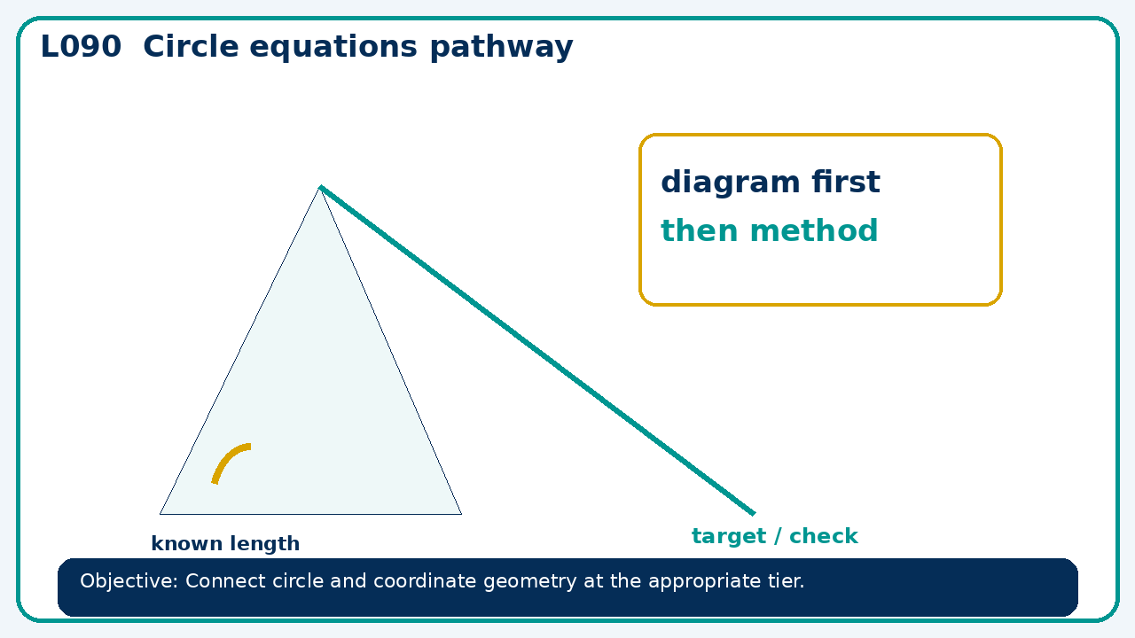

Connect & Check
- State the objective and timeline. Retrieve rates from graphs pathway or a prerequisite. Diagnose a common error before modelling.
- Write one starting question you want answered today.

Choose your route
Route A: Visual  Use a diagram, graph, table or annotation first. | Route B: Method  Use a worked method, formula or calculation chain first. | Route C: Explain  Start with words: what is known, what is changing, and why.

Share
- Pairs compare methods or predict a result for circle equations pathway. Ask for a reason, not only an answer.

Present
- Foundation: coordinates and circle measures.
- Higher: circle equations and tangent reasoning

Apply: supported to independent
Recall: Retrieve the key fact or method needed for circle equations pathway.
Working: ______________________________________________________________
Check/explanation: ____________________________________________________
Core practice: A circle has equation x²+y²=49. Find y-values when x=0 and when x=5.
Working: ______________________________________________________________
Check/explanation: ____________________________________________________
Reasoning: Can (7,7) lie on the circle x²+y²=49? Justify by substitution.
Working: ______________________________________________________________
Check/explanation: ____________________________________________________
Exam-style: Use a labelled diagram to calculate the missing value. State the theorem or formula and include units where needed.
Working: ______________________________________________________________
Check/explanation: ____________________________________________________

Recall & Review
- Revisit the objective. Learners solve a fresh item without prompts, explain a check, correct one error and record the next practice.
WWW: ________________________________ EBI: ________________________________

Recall & Review: feedback and extension integration
Lesson L090: Circle equations pathway
Objective: Connect circle and coordinate geometry at the appropriate tier.
Timing for a 60-minute lesson
0-7 Connect & Check; 7-14 Share; 14-25 Present/model; 25-44 Apply route choice/practice; 44-52 independent exam-style check; 52-60 Recall & Review, WWW/EBI and next step.
Recall & Review evidence
At the end of the lesson, solve a fresh question without prompts, explain one check, correct one error and record the next practice step.
What Went Well (WWW)
I selected the correct geometric fact, theorem, formula or transformation and used a clear diagram with appropriate labels and units.
Even Better If (EBI)
I will name the fact or theorem, show the substitution or construction step and check whether the size, direction and units of the result are reasonable.
Integrated stretch and deep challenge
Stretch: A circle has equation x²+y²=49. Find y-values when x=0 and when x=5.
Deep challenge: Can (7,7) lie on the circle x²+y²=49? Justify by substitution.
My next-step response

