
Reach for the Star | GCSE Mathematics 1MA1 | L091

Knowledge organiser: Proof and algebraic structure
Objective: Explain algebraic structure and build a logical argument.
Calculator condition: Non-calculator core; calculator optional only for checking where labelled.
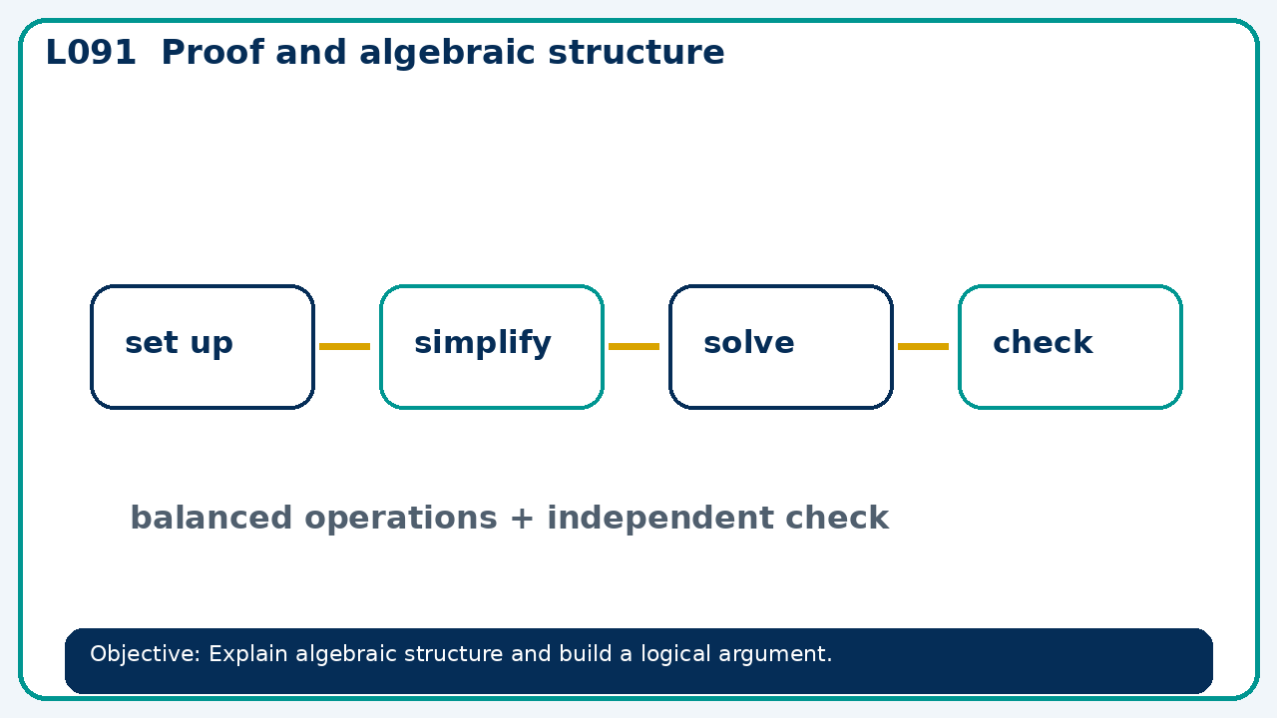

Core knowledge
- Foundation: equivalence and numerical counterexamples.
- Higher: algebraic fractions, manipulation and proof

Method checklist
- Identify what the question is asking.
- Choose the relevant representation or method.
- Show working clearly and label units.
- Check the answer against the original context.
- Write one sentence explaining why the answer is reasonable.

Common error to avoid
- Prove the sum of three consecutive integers is divisible by 3.

