
Reach for the Star | GCSE Mathematics 1MA1 | L092

Knowledge organiser: Mixed modelling and checking
Objective: Form a mathematical model, solve it and interpret its limitations.
Calculator condition: Non-calculator core; calculator optional only for checking where labelled.
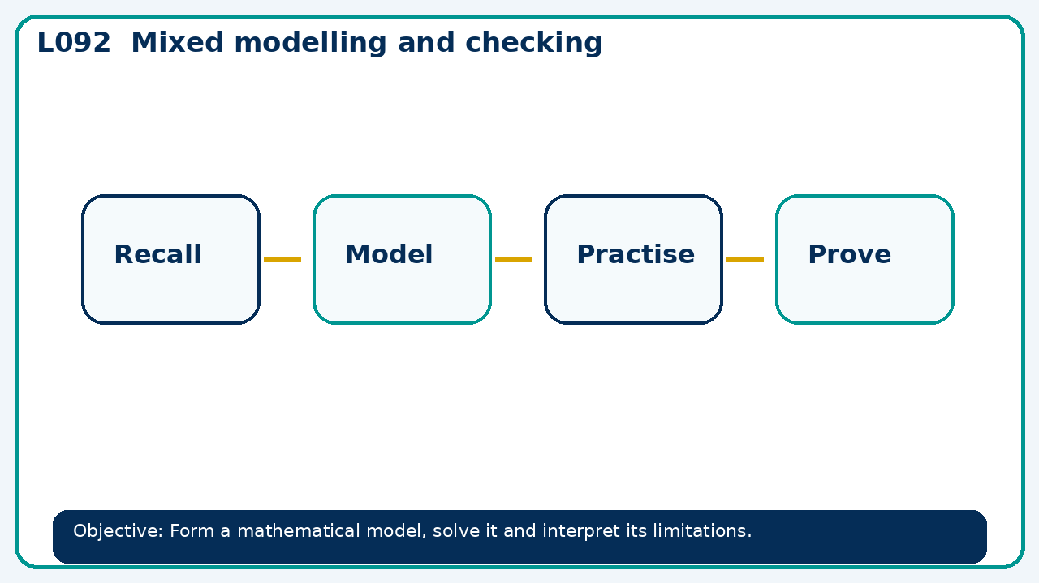

Core knowledge
- Compare models for a situation; identify assumptions and check reasonableness

Method checklist
- Identify what the question is asking.
- Choose the relevant representation or method.
- Show working clearly and label units.
- Check the answer against the original context.
- Write one sentence explaining why the answer is reasonable.

Common error to avoid
- A rectangle has perimeter 40 cm. Express area in terms of width x and find width for length 12 cm.

