
Reach for the Star | GCSE Mathematics 1MA1 | L093

Knowledge organiser: Number and ratio consolidation
Objective: Retrieve and connect number, ratio and proportional methods.
Calculator condition: Non-calculator core; calculator optional only for checking where labelled.
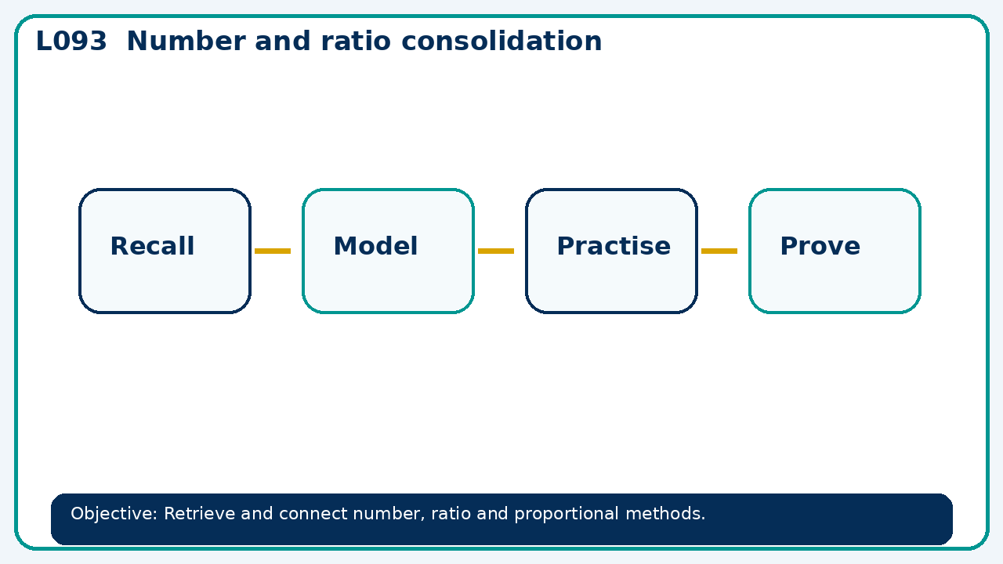

Core knowledge
- Interleave methods without labels; use diagnostics to reteach the weakest link

Method checklist
- Identify what the question is asking.
- Choose the relevant representation or method.
- Show working clearly and label units.
- Check the answer against the original context.
- Write one sentence explaining why the answer is reasonable.

Common error to avoid
- A price increases 10% then 10%. Explain why total increase is 21%, not 20%.

