
Reach for the Star | GCSE Mathematics 1MA1 | L094

Knowledge organiser: Algebra consolidation
Objective: Retrieve and connect algebraic methods at the chosen tier.
Calculator condition: Non-calculator core; calculator optional only for checking where labelled.
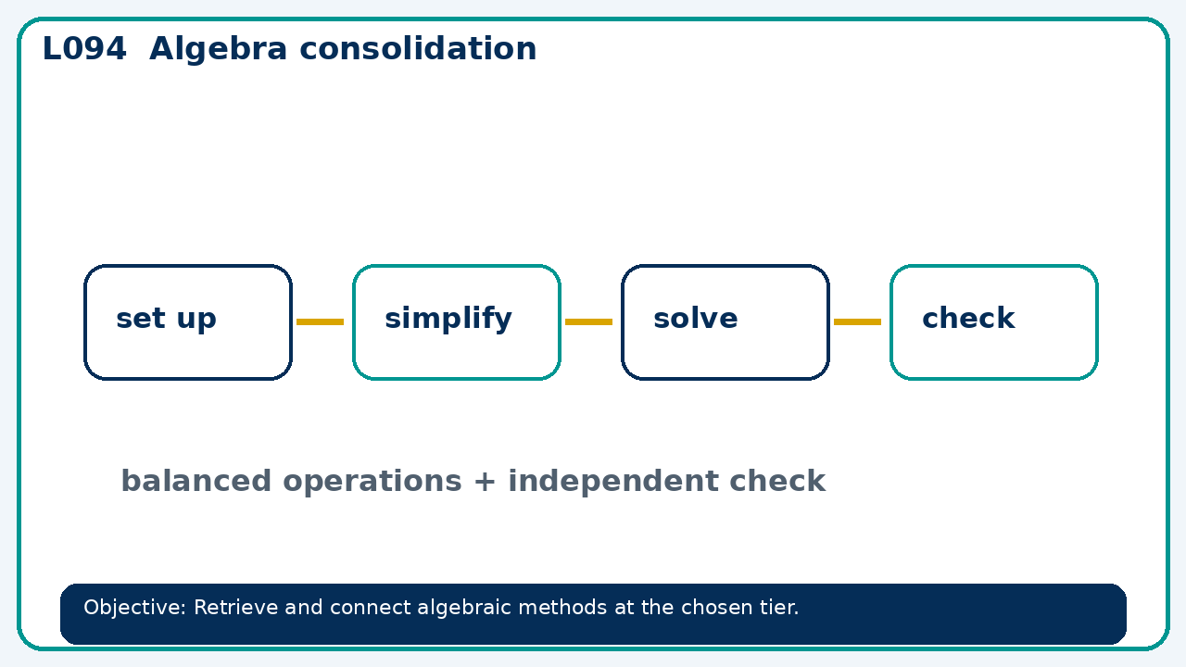

Core knowledge
- Compare equations, expressions and graphs; require a method-selection explanation

Method checklist
- Identify what the question is asking.
- Choose the relevant representation or method.
- Show working clearly and label units.
- Check the answer against the original context.
- Write one sentence explaining why the answer is reasonable.

Common error to avoid
- Find k so that x²+kx+12=(x+3)(x+4).

