
Reach for the Star | GCSE Mathematics 1MA1 | L095

Knowledge organiser: Geometry probability and statistics consolidation
Objective: Connect geometry, probability and statistics through mixed problems.
Calculator condition: Non-calculator core; calculator optional only for checking where labelled.
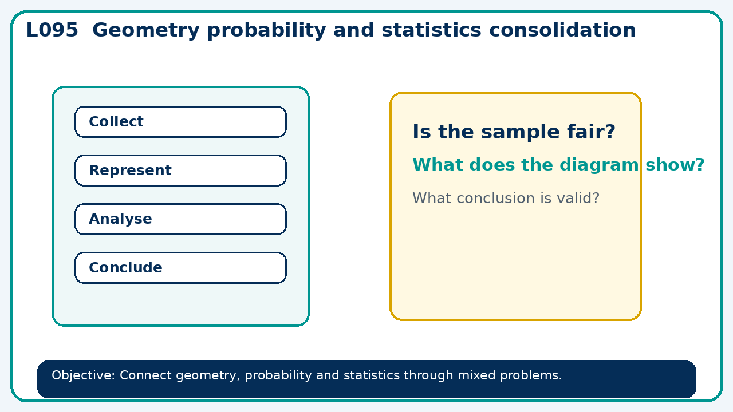

Core knowledge
- Select representations and units; check whether conclusions follow from evidence

Method checklist
- Identify what the question is asking.
- Choose the relevant representation or method.
- Show working clearly and label units.
- Check the answer against the original context.
- Write one sentence explaining why the answer is reasonable.

Common error to avoid
- A radius doubles. Compare the circle's area and circumference multipliers.

