
Reach for the Star | GCSE Mathematics 1MA1 | L095

Learner workbook: Geometry probability and statistics consolidation
Objective: Connect geometry, probability and statistics through mixed problems.
Calculator condition: Non-calculator core; calculator optional only for checking where labelled.
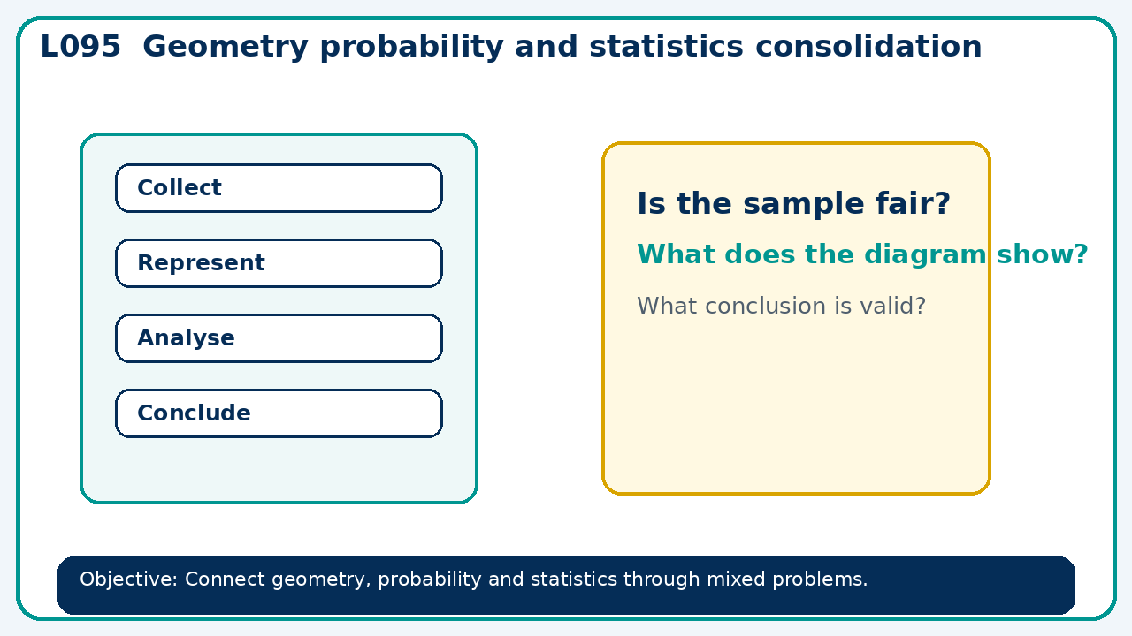

Connect & Check
- State the objective and timeline. Retrieve algebra consolidation or a prerequisite. Diagnose a common error before modelling.
- Write one starting question you want answered today.

Choose your route
Route A: Visual  Use a diagram, graph, table or annotation first. | Route B: Method  Use a worked method, formula or calculation chain first. | Route C: Explain  Start with words: what is known, what is changing, and why.

Share
- Pairs compare methods or predict a result for geometry probability and statistics consolidation. Ask for a reason, not only an answer.

Present
- Select representations and units; check whether conclusions follow from evidence

Apply: supported to independent
Recall: Retrieve the key fact or method needed for geometry probability and statistics consolidation.
Working: ______________________________________________________________
Check/explanation: ____________________________________________________
Core practice: A fair spinner has sectors 1,2,3,4. Find mean score over one spin and P(score≥3).
Working: ______________________________________________________________
Check/explanation: ____________________________________________________
Reasoning: A radius doubles. Compare the circle's area and circumference multipliers.
Working: ______________________________________________________________
Check/explanation: ____________________________________________________
Exam-style: A probability problem is presented with two stages. Complete the representation, calculate the probability and explain any assumption.
Working: ______________________________________________________________
Check/explanation: ____________________________________________________

Recall & Review
- Revisit the objective. Learners solve a fresh item without prompts, explain a check, correct one error and record the next practice.
WWW: ________________________________ EBI: ________________________________

Recall & Review: feedback and extension integration
Lesson L095: Geometry probability and statistics consolidation
Objective: Connect geometry, probability and statistics through mixed problems.
Timing for a 60-minute lesson
0-7 Connect & Check; 7-14 Share; 14-25 Present/model; 25-44 Apply route choice/practice; 44-52 independent exam-style check; 52-60 Recall & Review, WWW/EBI and next step.
Recall & Review evidence
At the end of the lesson, solve a fresh question without prompts, explain one check, correct one error and record the next practice step.
What Went Well (WWW)
I used my working and assessment evidence to identify the exact mathematical step that was secure and the specific misconception that needs attention.
Even Better If (EBI)
I will correct one precise step, explain why the correction works and complete a fresh delayed question without the original scaffold.
Integrated stretch and deep challenge
Stretch: A fair spinner has sectors 1,2,3,4. Find mean score over one spin and P(score ≥3).
Deep challenge: A radius doubles. Compare the circle's area and circumference multipliers.
My next-step response

