
Reach for the Star | GCSE Mathematics 1MA1 | L096

Knowledge organiser: Coverage diagnostic and repair
Objective: Identify remaining coverage gaps and set a targeted repair plan.
Calculator condition: Non-calculator core; calculator optional only for checking where labelled.
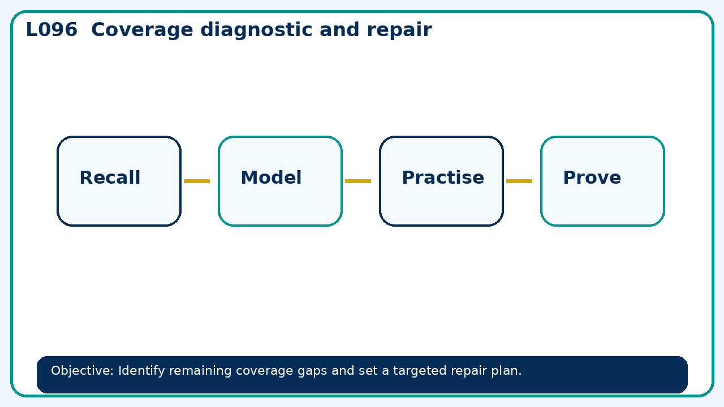

Core knowledge
- Use a balanced tier-specific diagnostic and teacher review of reasoning

Method checklist
- Identify what the question is asking.
- Choose the relevant representation or method.
- Show working clearly and label units.
- Check the answer against the original context.
- Write one sentence explaining why the answer is reasonable.

Common error to avoid
- An error log shows repeated percentage and equation mistakes. Propose two different fresh checks and what they test.

