
Reach for the Star | GCSE Mathematics 1MA1 | L097

Learner workbook: Mock paper 1 non-calculator
Objective: Apply the chosen tier’s content independently in mock Paper 1.
Calculator condition: Calculator allowed where labelled; non-calculator reasoning remains required.
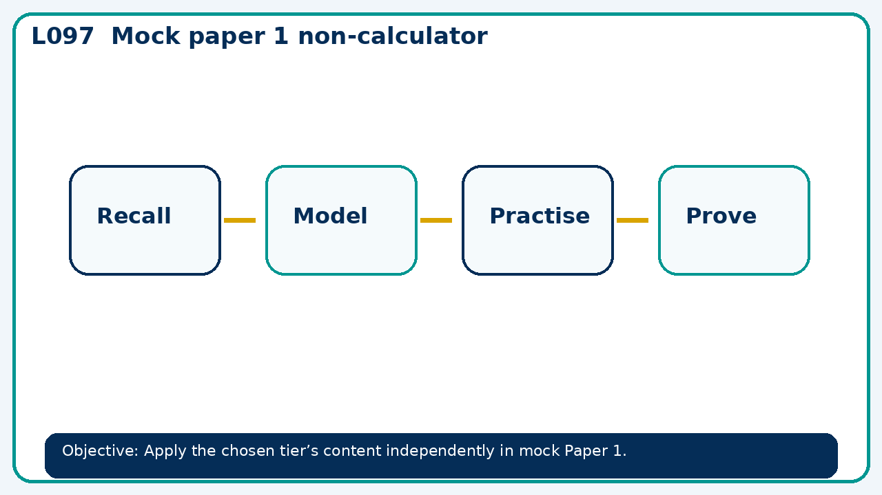

Connect & Check
- Confirm the tier, paper conditions and 45 minute section. State the objective and connect to the prior coverage diagnostic.
- Write one starting question you want answered today.

Choose your route
Route A: Visual  Use a diagram, graph, table or annotation first. | Route B: Method  Use a worked method, formula or calculation chain first. | Route C: Explain  Start with words: what is known, what is changing, and why.

Share
- Before timing begins, share one exam strategy and clarify how method marks are evidenced; do not discuss answers during the assessment.

Present
- Explain paper instructions, time allocation and permitted equipment.
- Distribute the selected 45 minute tier section; maintain exam conditions.

Apply: supported to independent
Recall: Retrieve the key fact or method needed for mock paper 1 non-calculator.
Working: ______________________________________________________________
Check/explanation: ____________________________________________________
Core practice: For later feedback, not during timed work. Stretch: Without a calculator, find 7/12 of 84 and show a division-first method. Deep challenge: A learner gets 49 but writes only the answer on a two-mark question. Explain what evidence of method to add.
Working: ______________________________________________________________
Check/explanation: ____________________________________________________
Reasoning: A learner gets 49 but writes only the answer on a two-mark question. Explain what evidence of method to add.
Working: ______________________________________________________________
Check/explanation: ____________________________________________________
Exam-style: Solve an exam-style problem involving mock paper 1 non-calculator. Show working, include a check and interpret your answer.
Working: ______________________________________________________________
Check/explanation: ____________________________________________________

Recall & Review
- Collect scripts. Learners note confidence and one time-management decision; mark and give method feedback at the next lesson.
WWW: ________________________________ EBI: ________________________________

Recall & Review: feedback and extension integration
Lesson L097: Mock paper 1 non-calculator
Objective: Apply the chosen tier’s content independently in mock Paper 1.
Timing for a 60-minute lesson
0-7 Connect & Check; 7-14 Share; 14-25 Present/model; 25-44 Apply route choice/practice; 44-52 independent exam-style check; 52-60 Recall & Review, WWW/EBI and next step.
Recall & Review evidence
At the end of the lesson, solve a fresh question without prompts, explain one check, correct one error and record the next practice step.
What Went Well (WWW)
I used my working and assessment evidence to identify the exact mathematical step that was secure and the specific misconception that needs attention.
Even Better If (EBI)
I will correct one precise step, explain why the correction works and complete a fresh delayed question without the original scaffold.
Integrated stretch and deep challenge
Stretch: Without a calculator, find 7/12 of 84 and show a division-first method.
Deep challenge: A learner gets 49 but writes only the answer on a two-mark question. Explain what evidence of method to add.
My next-step response

