
Reach for the Star | GCSE Mathematics 1MA1 | L098

Knowledge organiser: Mock paper 2 calculator
Objective: Apply the chosen tier’s content independently in mock Paper 2.
Calculator condition: Calculator allowed where labelled; non-calculator reasoning remains required.
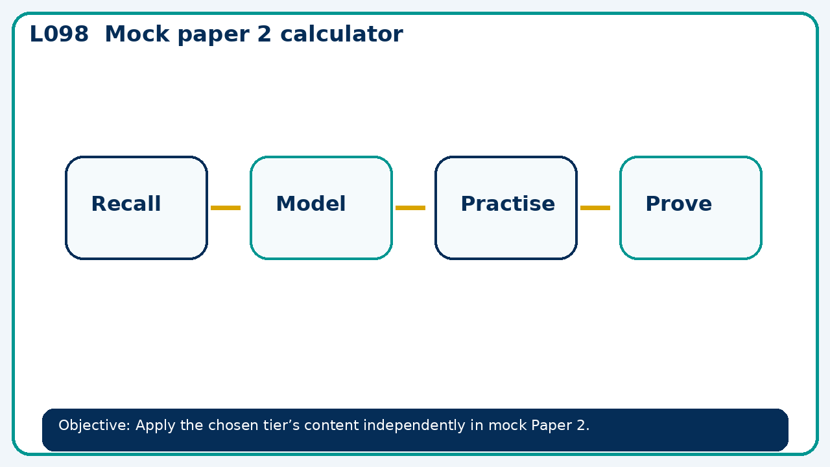

Core knowledge
- Explain paper instructions, time allocation and permitted equipment.
- Distribute the selected 45 minute tier section; maintain exam conditions.

Method checklist
- Identify what the question is asking.
- Choose the relevant representation or method.
- Show working clearly and label units.
- Check the answer against the original context.
- Write one sentence explaining why the answer is reasonable.

Common error to avoid
- A display shows 6.999999 after a calculation expected to be whole. What should the learner check before rounding?

