
Reach for the Star | GCSE Mathematics 1MA1 | L101

Knowledge organiser: Paper 2 feedback and repair
Objective: Interpret feedback on mock Paper 2 and repair a priority misconception.
Calculator condition: Non-calculator core; calculator optional only for checking where labelled.
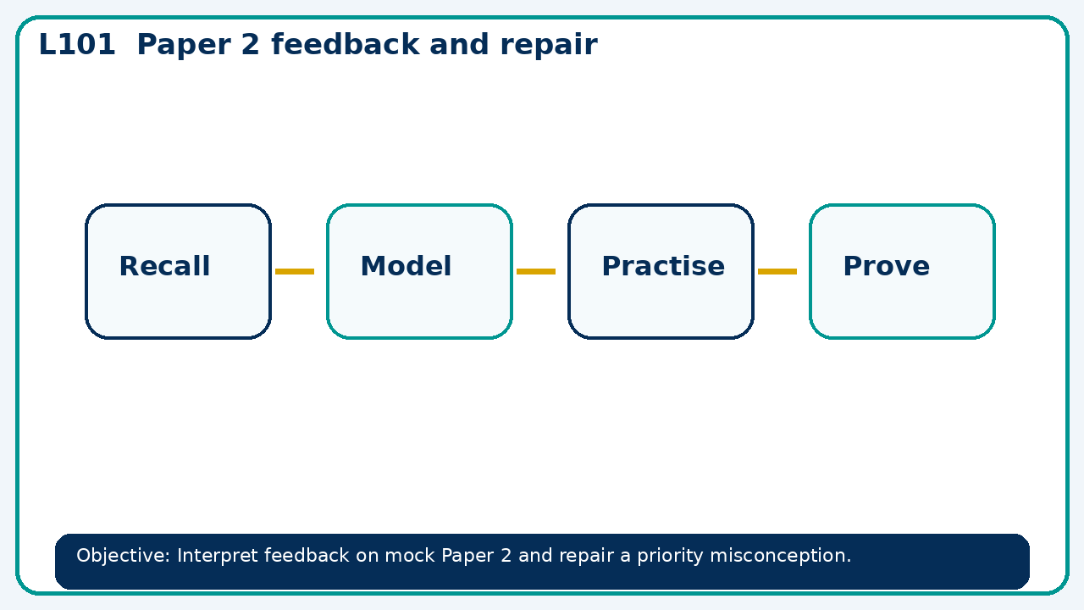

Core knowledge
- Use a 30 minute feedback conference with a worked-example/problem pair.
- Agree the next independent check

Method checklist
- Identify what the question is asking.
- Choose the relevant representation or method.
- Show working clearly and label units.
- Check the answer against the original context.
- Write one sentence explaining why the answer is reasonable.

Common error to avoid
- A calculator input 420×1+0.07² is used for growth. Identify the bracket error.

